**1. Introduction of Project**

**1.1 Introduction**

The online banking application has been developed to overwrite the problems prevailing in the practicing manual systems. This software is supported to eliminate and, in some cases, reduce the heart ships faced by this existing system. Moreover, this is stem is designed for the particular need of the company to carry out operation in a smooth and effective manner.

The application is reduced as much as possible to avoid errors while entering the data. It also provides error message while entering invalid data. This by this all it proves it is user friendly. Online banking application, as described above, can lead to error free, secure, reliable and fast management system. It can assist the user to concentrate on their other activities rather to concentrate on the record keeping. Thus, it will help Organization in better utilization of resources.

**1.2 Scope of the project online banking application.**

It may help collecting perfect management in details. In a very short time, the collection will be obvious simple and sensible. It will help a person to know the management of fast year perfectly and vividly. It also helps in the current all work relative to online banking application. It will be also reduced the cost of collecting the management and collection procedures will go on smoothly.

Our project aims at business process automation that is we have tried to computerized various processes of an online banking application.

* In our computer system the person has to fill the various forms and number of copies of the forms can be easily generated at a time.
* In computer system it is not necessary to create the manifest but we can directly print it which save the time.
* To assist the staff in capturing the efforts spent on their respective working areas.
* To utilize resources in an effective manner of the increasing the productivity through automation.
* This is steam generates types of information that can be used for various purposes.
* It satisfies the user requirement.
* Be easy to understand by the user and operator.
* Busy to operate.
* Have a good user interface.
* Be expandable.
* Delivered on schedule with in the budget.

**2. Proposed System**

**Proposed System**

Proposed system is an automated Bank Management System. Through our software user can add account, deposit, withdraw, display account list in quick time. Our proposed system has the following advantages.

➢ User friendly interface

➢ Fast access to database

➢ Less error

➢ More Storage Capacity

➢ Search facility

➢ Look and Feel Environment

➢ Quick transaction

All the manual difficulties in managing a Bank have been rectified by implementing computerization.

**2.1 Objectives**

The main objective is to maintain the inventory records of passengers.

1. To keep the record of the Accounts.
2. To manage users’ data.
3. To reduce paperwork.
4. Data can be easily accessed, hence user-friendly.
5. To obtain a highly reliable, accurate, and efficient system is the main objective of this project.

**2.2 Requirement Engineering**

To study the system, you need to collect facts. Facts are expressed in qualitative form called as data. Success of any requirement any investigation depends upon availability of accurate and reliable data. These depend on appropriate method chosen for data collection. The specific methods used for collecting data are fact finding techniques.

**The different methods used by analyst are:**

Interview

Onside

Observation

Record

Review

Questionary

**In this project we are using the method of:**

**Interview:**

Interview technique is used to collect information from individual or from groups. Analyst should select respondent how are related to system under study. In this method interviewer that is analyst seats face to face with respondent and record his responses.

The information collected is likely to be more accurate and reliable because the interviewer can clear up their doubts and crass check the despondence. This method also helps to find the area of misunderstanding, unrealistic expectations and future problems of the prose system.

**Observation:**

Unlike the other fact-finding technique, in this method the analyst himself visits the organization on observes and understands the flow of document, working of requirement system, the users of the system etc. For this method to be adopted it takes and analyst to perform this job as he knows which points should be noticed and highlighted. In analyst may observe the unwanted things as well and simply cause delay in the development of the new system.

* 1. **Requirement Gathering**

The waterfall model is a sequential (non-iterative) design process, used in software development process, in which process is seen as flowing steadily downwards (like a waterfall) through the phases of conception, initiation, analysis, design, construction, testing, production/implementation & maintenance. Despite the development of new software development process models, the waterfall model is still the dominant process model with over a third of software developers still using it.

* 1. **Software Requirement**

The software requirements are description of features and functionalities of the target system. SRS defines how the intended software will interact with hardware, external interfaces, speed of operation, response time of system, portability of software across various platforms, maintainability, speed of recovery after crashing, Security, Quality, Limitations etc. It is the responsibility of system analyst to document the requirements in technical language so that they can be comprehended and useful by the software development team.

SRS should come up with following features:

* User Requirements are expressed in natural language.
* Technical requirements are expressed in structured language, which is sued inside the organizations.
* Design description should be written in Pseudo code.
* Format of Forms and GUI screen prints.
* Conditional and mathematical notations for DFDs etc.
* Technical requirements are expressed in structured language.
* Format of Forms and GUI screen prints.

Broadly software requirements should be categorized in two categories:

**Functional Requirements:**

Requirements, which are related to functional aspect of software fall into this category. They define functions and functionality within and from the software system.

**Non-Functional Requirements:**

Requirements, which are not related to functional aspect of software, fall into this category. They are implicit or expected characteristics of software, which users make assumption of.

**Software Requirement:**

**What is Flask?**

Flask is a web application framework written in Python. It was developed by Armin Ronacher, who led a team of international Python enthusiasts called Poocco. Flask is based on the Werkzeg WSGI toolkit and the Jinja2 template engine. Both are Pocco projects.

Flask is a web framework, it’s a Python module that lets you develop web applications easily. It has a small and easy-to-extend core: it’s a microframework that doesn’t include an ORM (Object Relational Manager) or such features.

It does have many cool features like URL routing, template engine. It is a WSGI web app framework.

**WSGI:** The Web Server Gateway Interface (Web Server Gateway Interface, WSGI) has been used as a standard for Python web application development. WSGI is the specification of a common interface between web servers and web applications.

**Werkzeug:** Werkzeug is a WSGI toolkit that implements requests, response objects, and utility functions. This enables a web frame to be built on it. The Flask framework uses Werkzeg as one of its bases.

* 1. **Database Requirement:**

**Introduction to MySQL:**

* MySQL is a relational database management system.
* MySQL is open-source.
* MySQL is free.
* MySQL is ideal for both small and large applications.
* MySQL is very fast, reliable, scalable, and easy to use.
* MySQL is cross-platform.
* MySQL is compliant with the ANSI SQL standard.
* MySQL was first released in 1995.

**Features of MySQL:**

* Open Source
* Quick and Reliable
* Scalable
* Data Types
* Character Sets
* Secure
* Supports Large Databases

**3. System Analysis**

**3.1 Data Flow Diagram:**

**Zero Level DFD:**



**First Level DFD:**



**Second Level DFD process-1:**

Registration Info

Verify data

Valid User

Register Info

Update

Login Info

**Second Level DFD process-2:**

User Data

User Data

CUSTOMER

Personal Details

Account Request

Response

Verified_ Appl

update

Retrieve

**Second Level DFD process-3:**



Request for Money Transfer

**Second Level DFD process-4:**



**3.2 Entity Relationship Diagram:**



**3.3 Class Diagram:**



**3.4 Use Case Diagram:**



**3.5 Sequence Diagram:**



**4.** **System Designs**

**4.1 Database Design**

**1. Registration Table**

|  |  |  |  |  |  |
| --- | --- | --- | --- | --- | --- |
| **Field** | **Type** | **Null** | **Key** | **Default** | **Extra** |
| Rid | Int | No | Pri | Null | Auto_increment |
| Fname | Varchar (255) | Yes |  | Null |  |
| Lname | Varchar (255) | Yes |  | Null |  |
| Phone | Bigint | Yes |  | Null |  |
| Email Id | Varchar (255) | Yes |  | Null |  |
| Password | Varchar (255) | Yes |  | Null |  |

**2. Account open Table**

|  |  |  |  |  |  |
| --- | --- | --- | --- | --- | --- |
| **Field** | **Type** | **Null** | **Key** | **Default** | **Extra** |
| Accno | Int | No | Pri | Null | Auto_increment |
| Fname | Varchar (255) | Yes |  | Null |  |
| Mname | Varchar (255) | Yes |  | Null |  |
| Lname | Varchar (255) | Yes |  | Null |  |
| Addrs | Varchar (255) | Yes |  | Null |  |
| City | Varchar (255) | Yes |  | Null |  |
| State | Varchar (255) | Yes |  | Null |  |
| Pincode | Int | Yes |  | Null |  |
| Nominee | Varchar (255) | Yes |  | Null |  |
| Atype | Varchar (255) | Yes |  | Null |  |
| Phone | Bigint | Yes |  | Null |  |
| Emailid | Varchar (255) | Yes |  | Null |  |
| Gender | Varchar (255) | Yes |  | Null |  |
| Balance | Bigint | Yes |  | Null |  |
| Opendate | Date | Yes |  | Null |  |

**3. Deposit**

|  |  |  |  |  |  |
| --- | --- | --- | --- | --- | --- |
| **Field** | **Type** | **Null** | **Key** | **Default** | **Extra** |
| Did | Int | No | Pri | Null | Auto_increment |
| Accno | Int | Yes | Mul | Null |  |
| Dname | Varchar (255) | Yes |  | Null |  |
| Damount | Int | Yes |  | Null |  |
| Ddate | Date | Yes |  | Null |  |

**4. Withdraw**

|  |  |  |  |  |  |
| --- | --- | --- | --- | --- | --- |
| **Field** | **Type** | **Null** | **Key** | **Default** | **Extra** |
| Wid | Int | No | Pri | Null | Auto_increment |
| Accno | Int | Yes | Mul | Null |  |
| Wname | Varchar (255) | Yes |  | Null |  |
| Wamount | Int | Yes |  | Null |  |
| Wdate | Date | Yes |  | Null |  |

**5. Passbook**

|  |  |  |  |  |  |
| --- | --- | --- | --- | --- | --- |
| **Field** | **Type** | **Null** | **Key** | **Default** | **Extra** |
| Tid | Int | No | Pri | Null | Auto_increment |
| Accno | Int | Yes | Mul | Null |  |
| Tdate | Date | Yes |  | Null |  |
| Credit | Int | Yes |  | Null |  |
| Debit | Date | Yes |  | Null |  |
| Balance | Int | Yes |  | Null |  |

**6. Loans**

|  |  |  |  |  |  |
| --- | --- | --- | --- | --- | --- |
| **Field** | **Type** | **Null** | **Key** | **Default** | **Extra** |
| Id | Int | No | Pri | Null | Auto_increment |
| Loantype | Varchar (255) | Yes |  | Null |  |
| Rate | Decimal (4,2) | Yes |  | Null |  |

**7. Loan Application**

|  |  |  |  |  |  |
| --- | --- | --- | --- | --- | --- |
| **Field** | **Type** | **Null** | **Key** | **Default** | **Extra** |
| Id | Int | No | Pri | Null | Auto_increment |
| Accno | Int | Yes | Mul | Null |  |
| Fname | Varchar (255) | Yes |  | Null |  |
| Mname | Varchar (255) | Yes |  | Null |  |
| Lname | Varchar (255) | Yes |  | Null |  |
| Email | Varchar (255) | Yes |  | Null |  |
| Contact | Bigint | Yes |  | Null |  |
| Addrs | Varchar (255) | Yes |  | Null |  |
| City | Varchar (255) | Yes |  | Null |  |
| State | Varchar (255) | Yes |  | Null |  |
| Loantype | Varchar (255) | Yes |  | Null |  |
| Amount | Bigint | Yes |  | Null |  |
| Tenure | Int | Yes |  | Null |  |
| Status | Varchar (255) | Yes |  | Null |  |
| Submitdate | Date | Yes |  | Null |  |

**8. Loanview**

|  |  |  |  |  |  |
| --- | --- | --- | --- | --- | --- |
| **Field** | **Type** | **Null** | **Key** | **Default** | **Extra** |
| Accno | Int | Yes |  | Null |  |
| Loantype | Varchar (255) | Yes |  | Null |  |
| Amount | Bigint | Yes |  | Null |  |
| Rate | Decimal (4,2) | Yes |  | Null |  |
| Tenure | Int | Yes |  | Null |  |

**9. Loan Calculation**

|  |  |  |  |  |  |
| --- | --- | --- | --- | --- | --- |
| **Field** | **Type** | **Null** | **Key** | **Default** | **Extra** |
| Id | Int | No | Pri | Null | Auto_increment |
| Accno | Int | Yes |  | Null |  |
| Amount | Bigint | Yes |  | Null |  |
| Interest | Decimal (4,2) | Yes |  | Null |  |
| Tenure | Int | Yes |  | Null |  |
| Totalpay | Decimal(15,2) | Yes |  | Null |  |
| Monthpay | Decimal(15,2) | Yes |  | Null |  |
| Totalpay | Decimal(16,2) | Yes |  | Null |  |

**10. Portal**

|  |  |  |  |  |  |
| --- | --- | --- | --- | --- | --- |
| **Field** | **Type** | **Null** | **Key** | **Default** | **Extra** |
| Id | Int | No | Pri | Null | Auto_increment |
| User | Varchar (255) | Yes |  | Null |  |
| Passwd | Varchar (255) | Yes |  | Null |  |

**5. Limitations**

**Limitations**

The limitations of an online banking project can vary depending on several factors, including the specific implementation, technological infrastructure, and user requirements. However, here are some common limitations that may be encountered:

**Security Risks:** Online banking projects face the constant challenge of maintaining robust security measures to protect customer data and financial transactions.

**Technical Issues:** Online banking relies on complex technological systems, including servers, networks, and software applications.

**User Trust and Acceptance**: Some individuals may have concerns about the security and privacy of their financial information when conducting transactions online. Building and maintaining trust among users is crucial for the success of online banking projects, and overcoming user skepticism and resistance can be a significant challenge.

**Customer Support:** While online banking offers self-service options, there may still be instances where customers require personalized assistance or have queries.

It's important to note that many of these limitations can be mitigated or addressed through diligent planning, implementation of security best practices, continuous monitoring, and proactive measures to improve user experience and accessibility.

**6. Proposed Enhancements**

**Proposed Enhancements**

There are several enhancements that can be considered for an online banking project to improve the user experience, security, functionality, and overall value offered to customers. Here are some proposed enhancements:

**Enhanced User Interface (UI) and User Experience (UX):** Focus on designing an intuitive and user-friendly interface that simplifies navigation and improves accessibility. Streamline the user experience by minimizing the number of steps required to complete common tasks and provide clear instructions and prompts.

**Mobile Banking Optimization:** As mobile usage continues to rise, optimize the online banking project for mobile devices, including smartphones and tablets. Develop a dedicated mobile app or ensure that the online banking website is responsive and mobile-friendly, allowing customers to access their accounts and perform transactions conveniently on the go.

**Real-time Notifications and Alerts:** Implement real-time notifications and alerts to keep customers informed about their account activities, such as balance updates, transaction confirmations, or suspicious activity alerts. These proactive notifications can enhance security and provide customers with peace of mind, while also reducing the risk of fraudulent transactions going unnoticed.

**7. Conclusion**

**Conclusion**

This project developed, incorporated all the activities involved in the browsing center.

It provides all necessary information to the management as well as the customer with the use of this system; the user can simply sit in front of the system and monitor all the activities without any physical movement of the file. Management can service the customer’s request best in time.

The system provides quickly and valuable information. These modules have been integrated for effective use of the management for future forecasting and for the current need.

**8. Bibliography**

**Bibliography**

For Flask

* <https://www.javatpoint.com/flask-tutorial>
* <https://www.tutorialspoint.com/flask/index.htm>

For MySQL

* <https://www.mysql.com/>
* <https://www.mysqltutorial.org/>

**9. Annexure**

**9.1 User Interface Screen**

**1. Home**

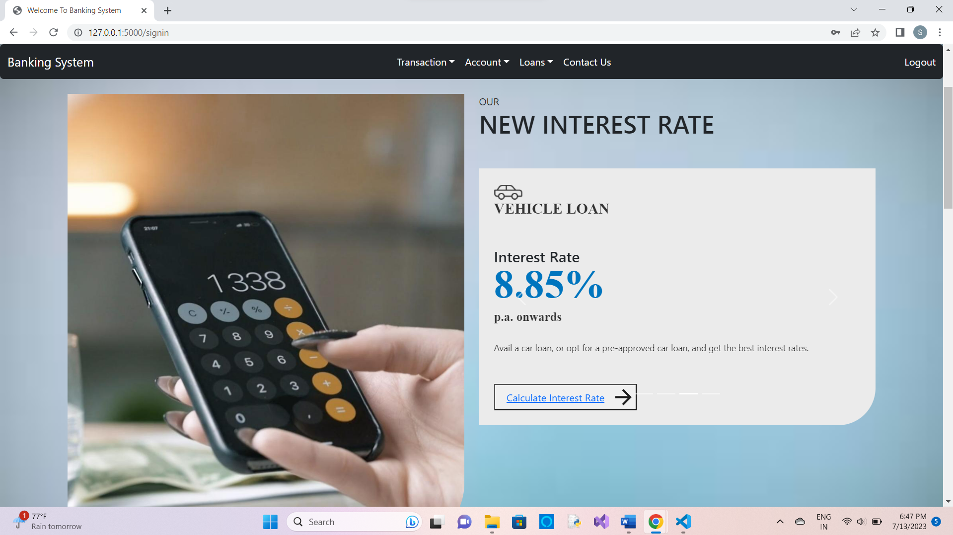

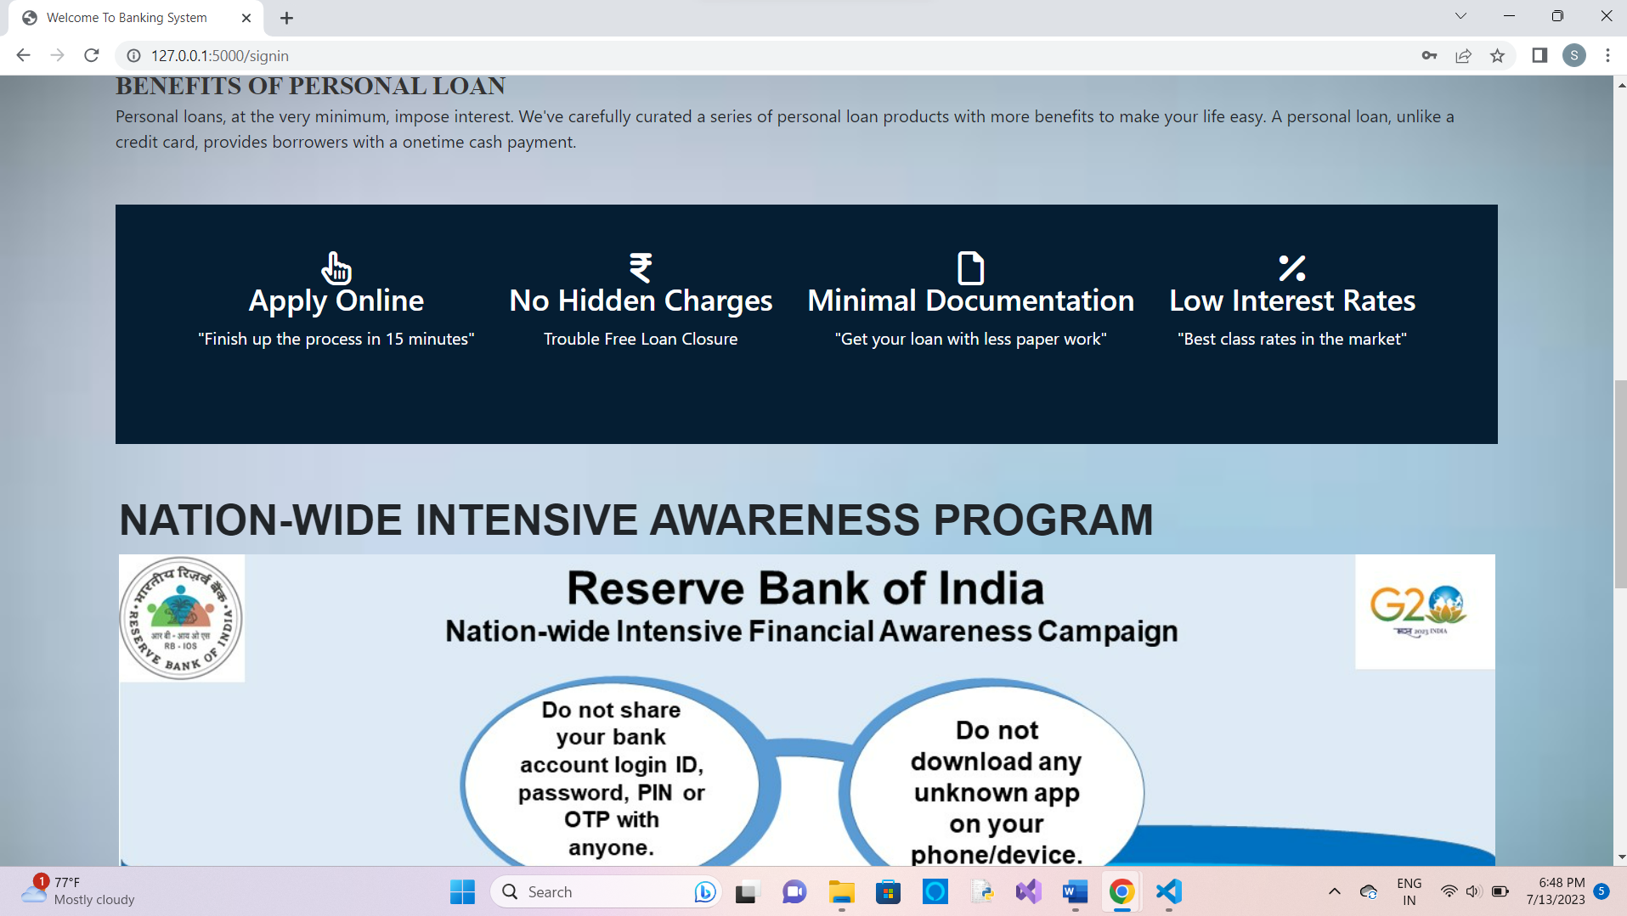

**2. New Account Opening**

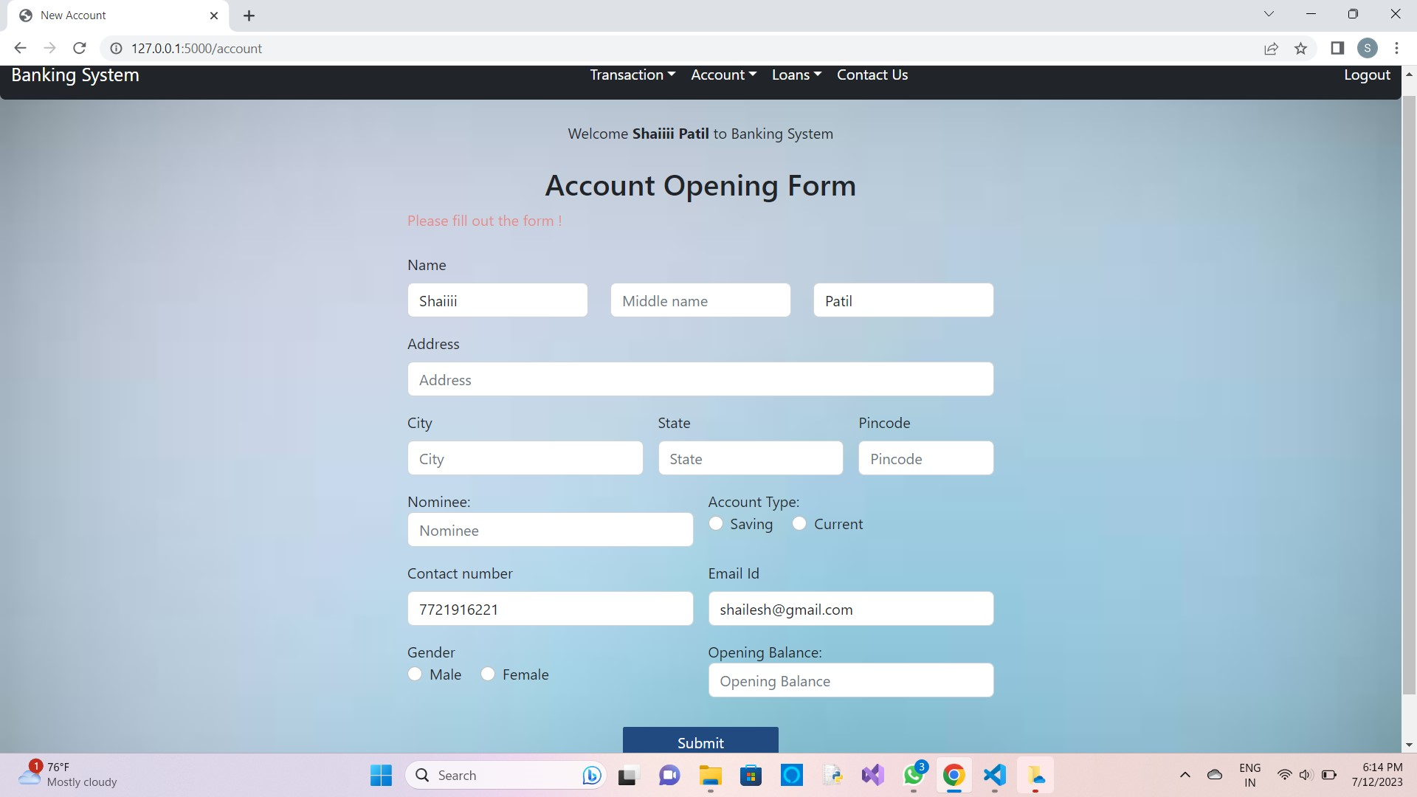

**3. Deposit Money**

3.1 Check if account exists

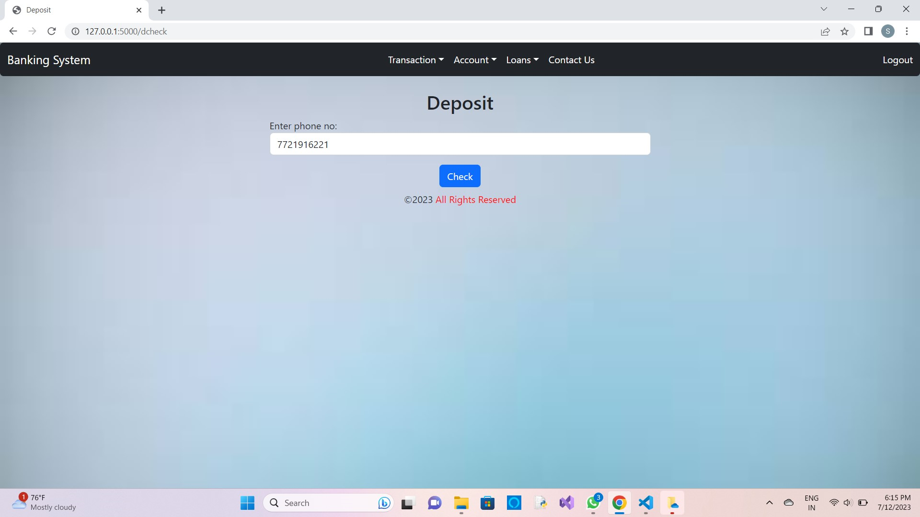

3.2 After Confirming

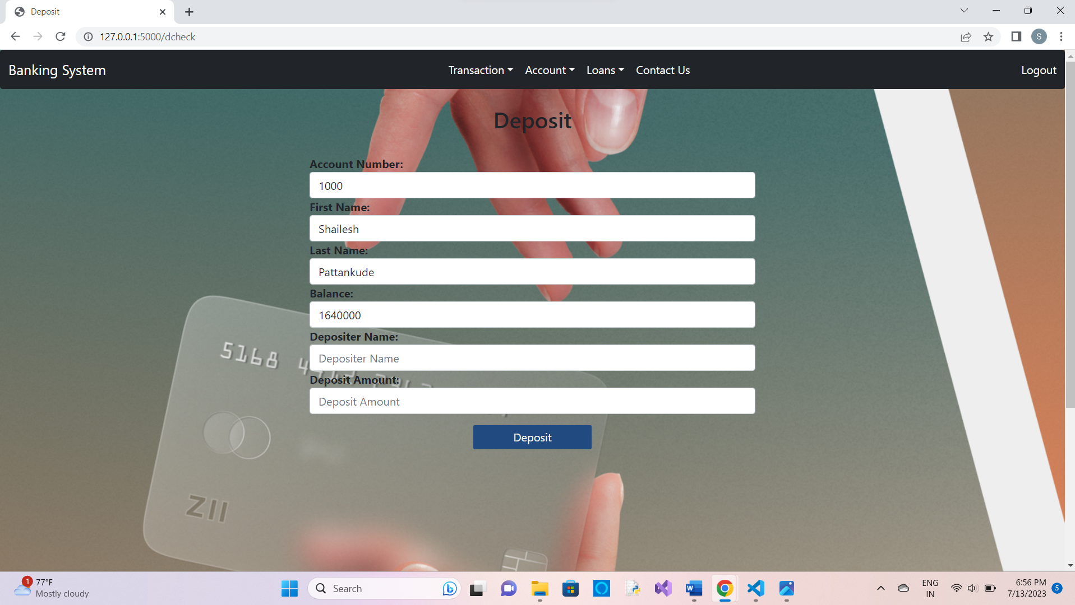

**4. Withdraw Money**

4.1 Check if account exists

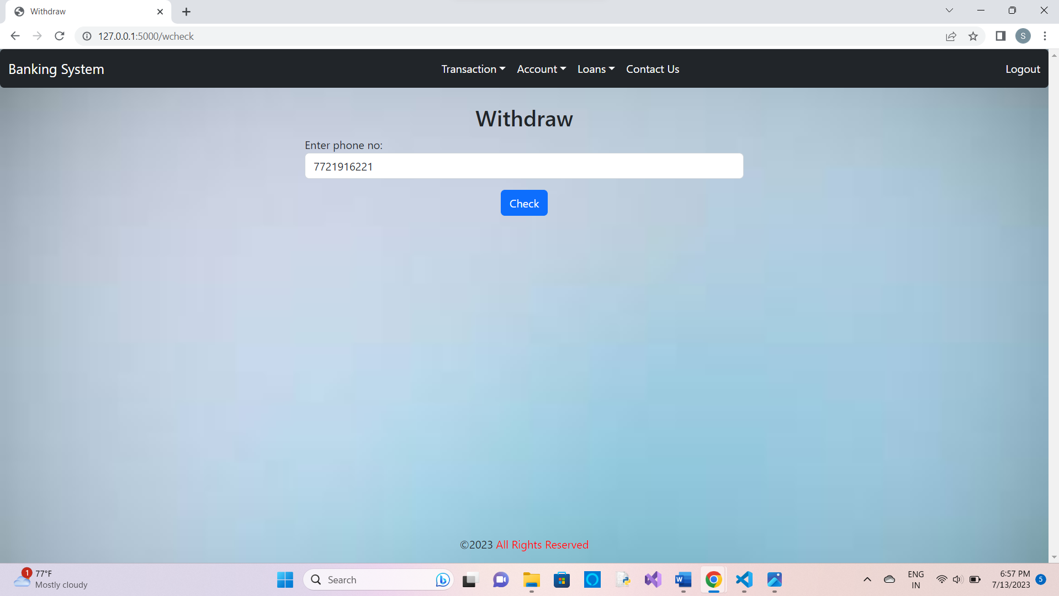

4.2 After confirming

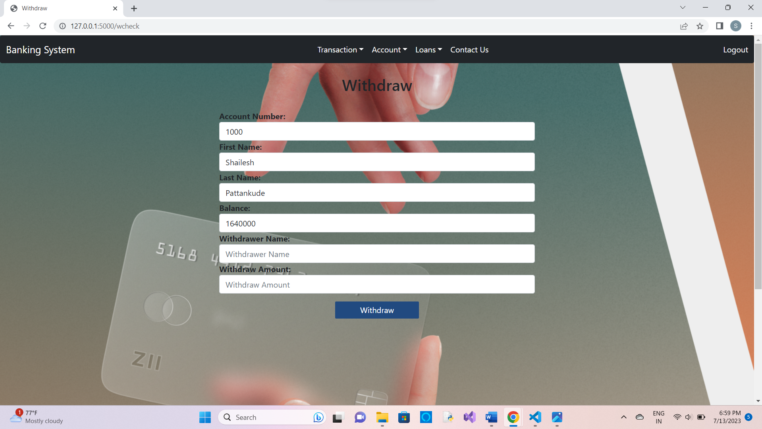

**5. Balance Enquiry**

5.1 Check if account exists

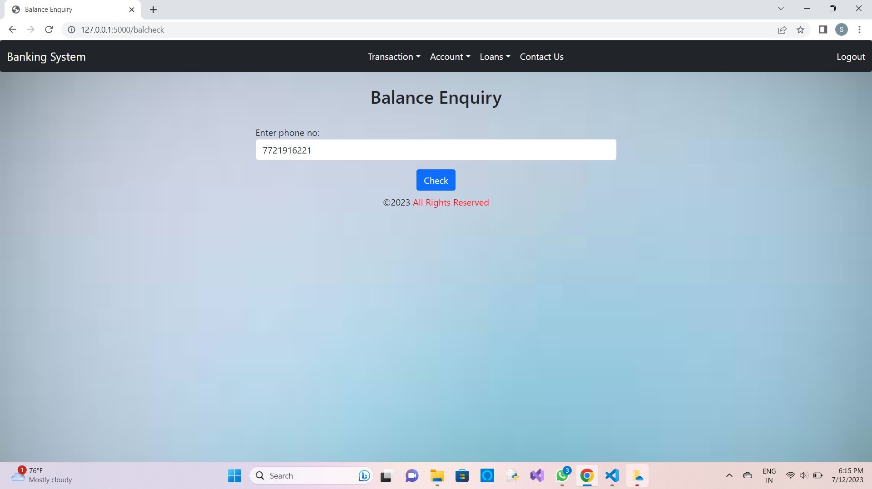

5.2 After confirming

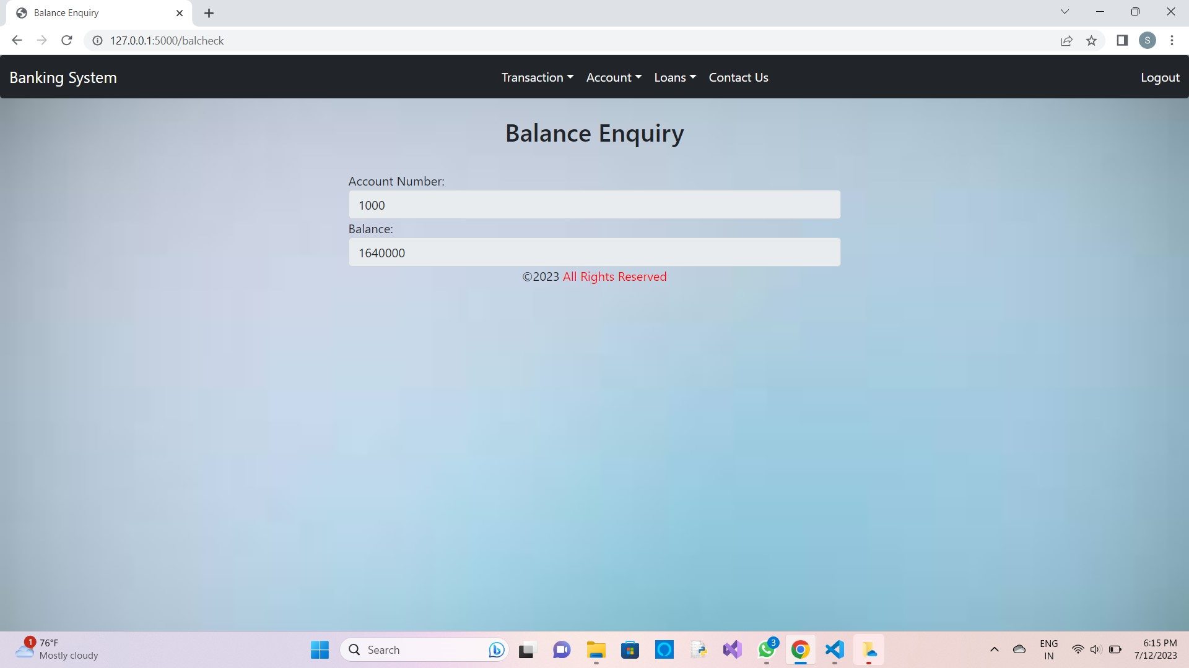

**6. Account Details**

6.1 Check if account exists

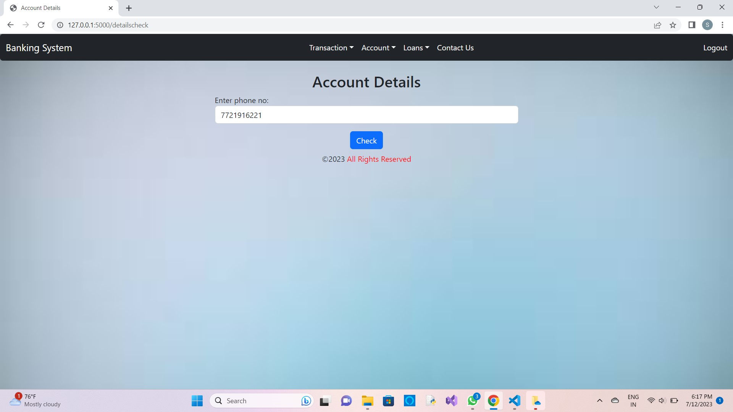

6.2 After confirming

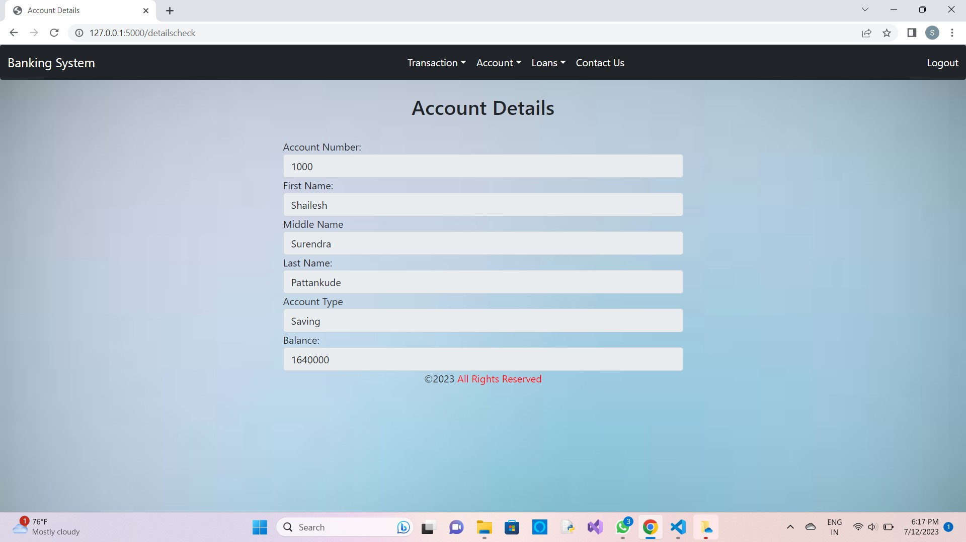

**7. Mini-statement**

7.1 Check if account exists

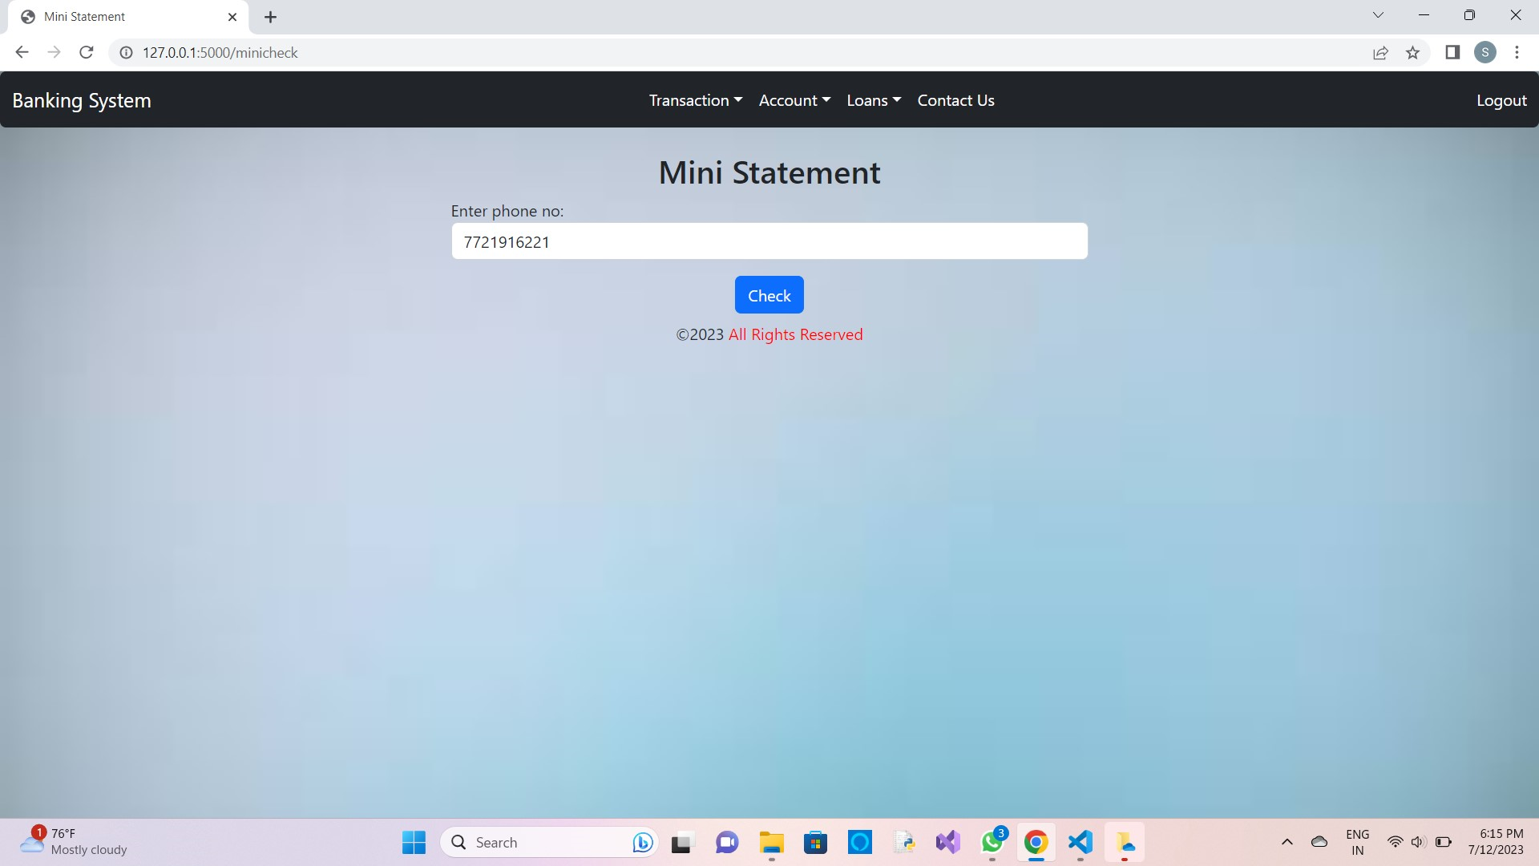

7.2 After confirming

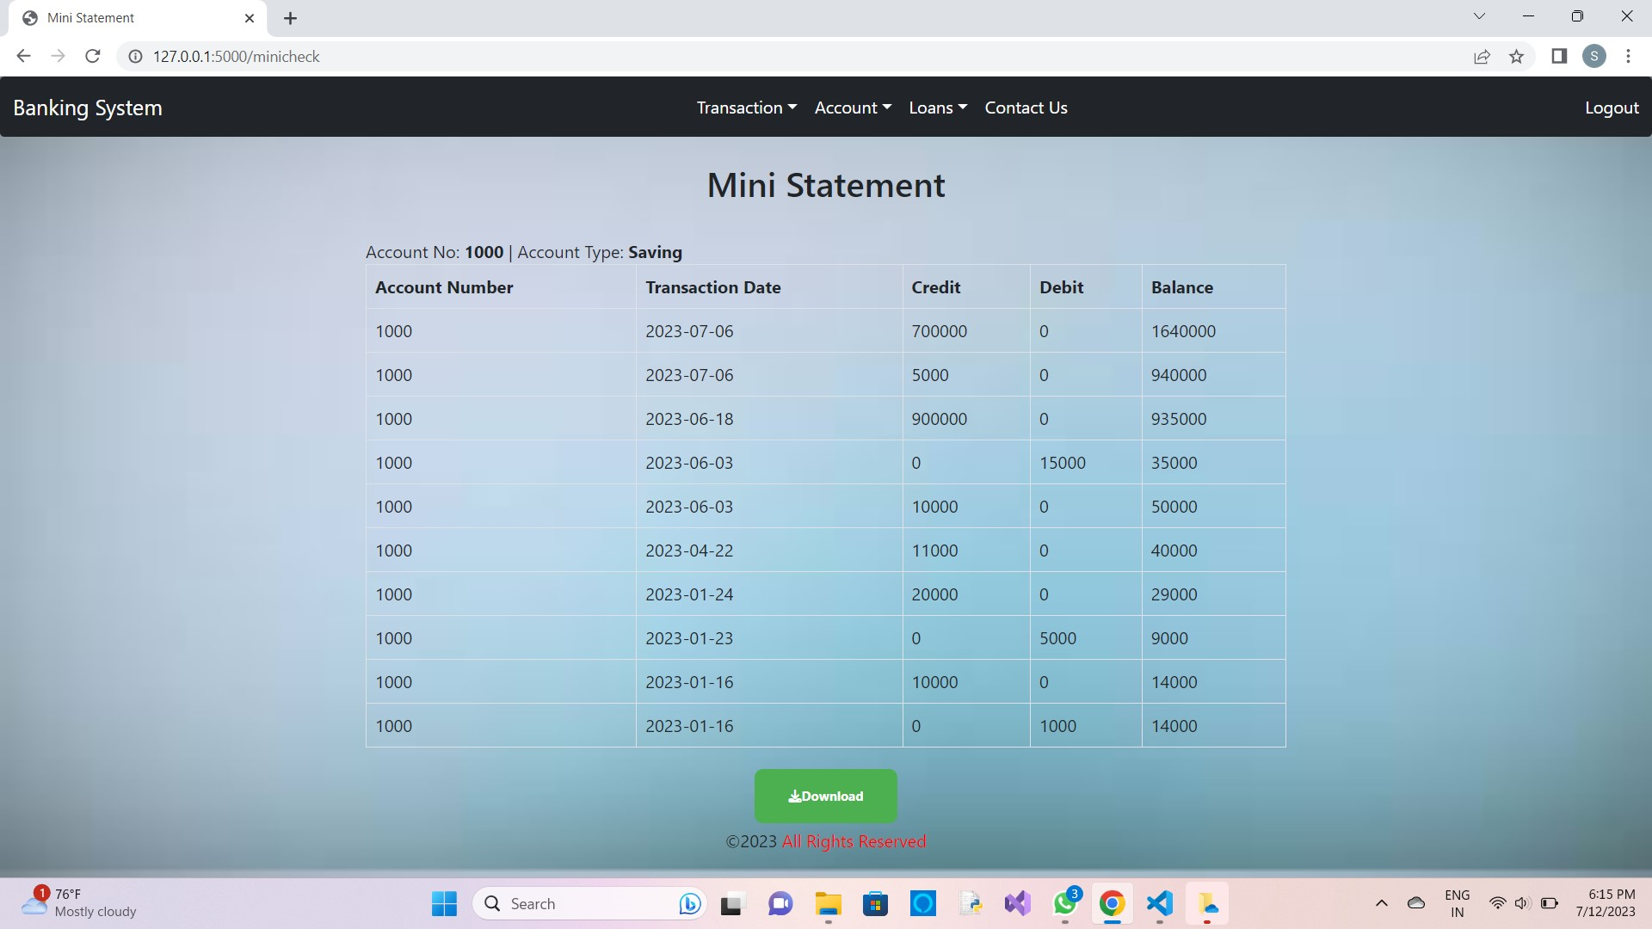

**8. Passbook**

8.1 Check if account exists

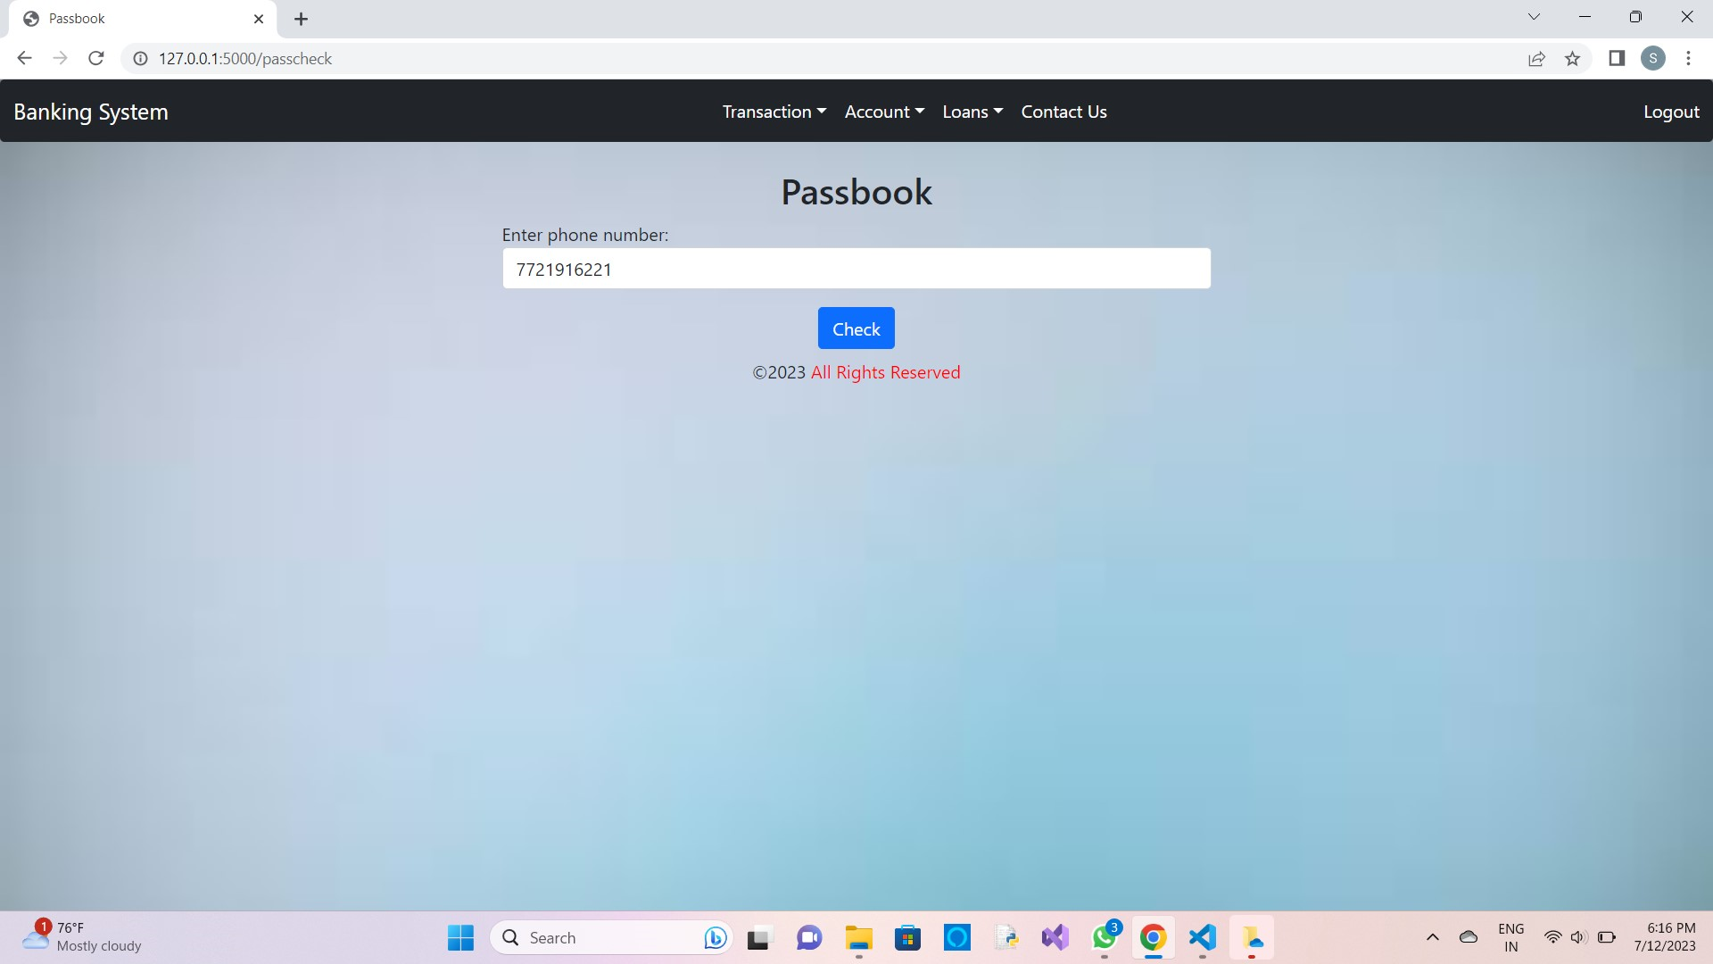

8.2 After confirming

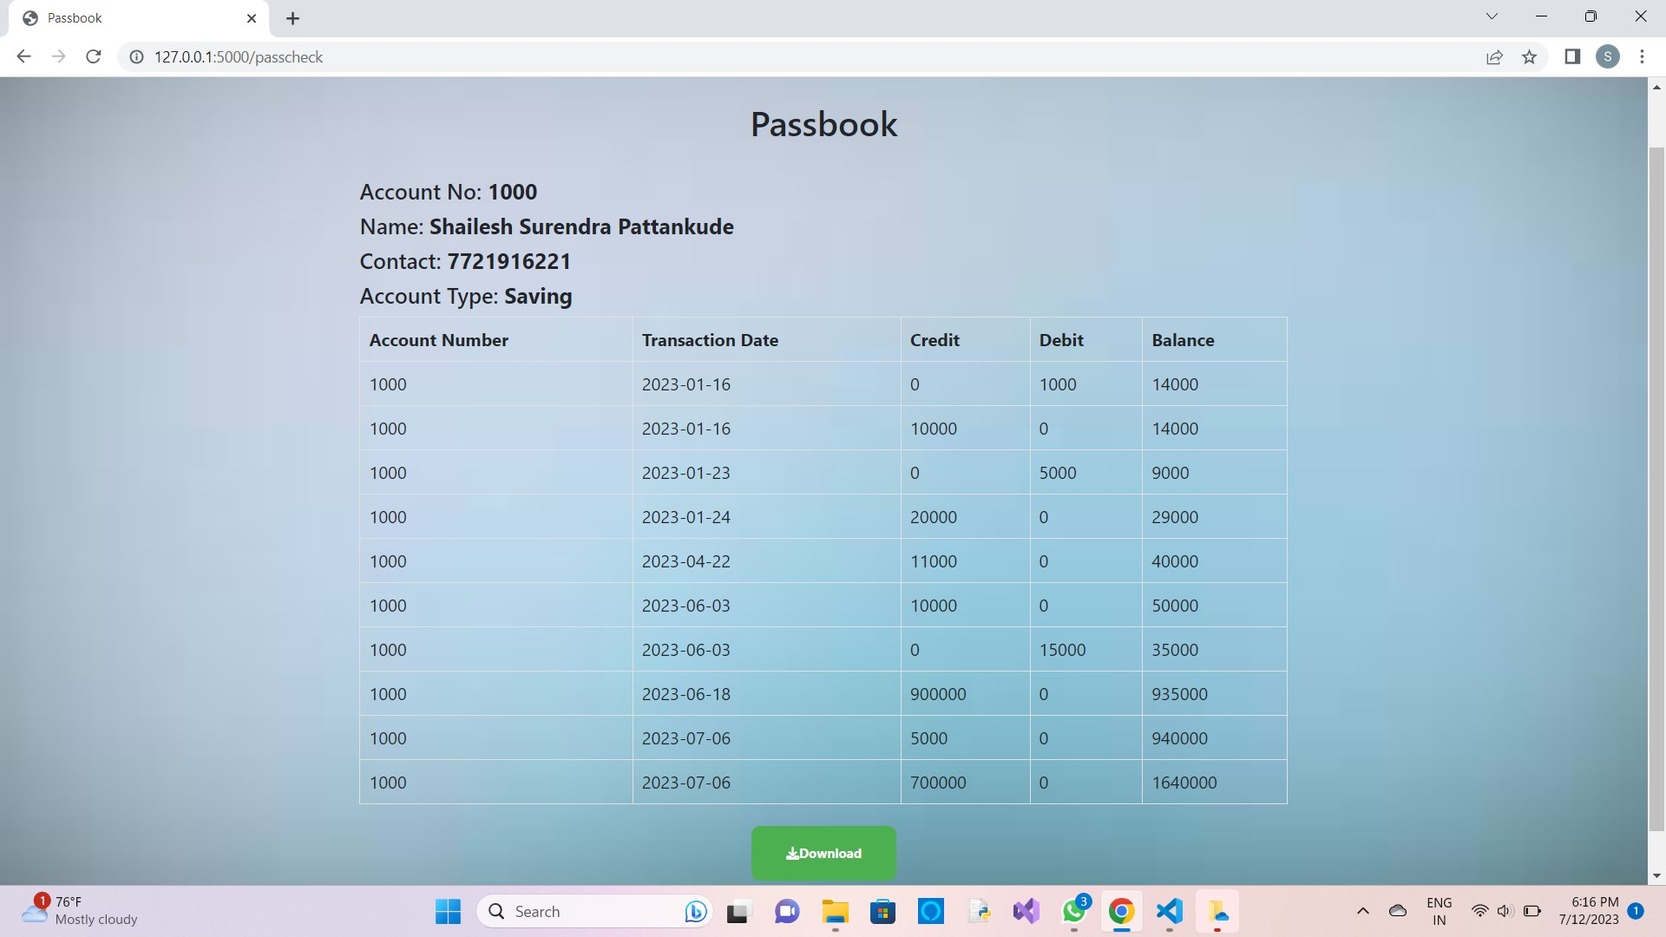

**9. Loans**

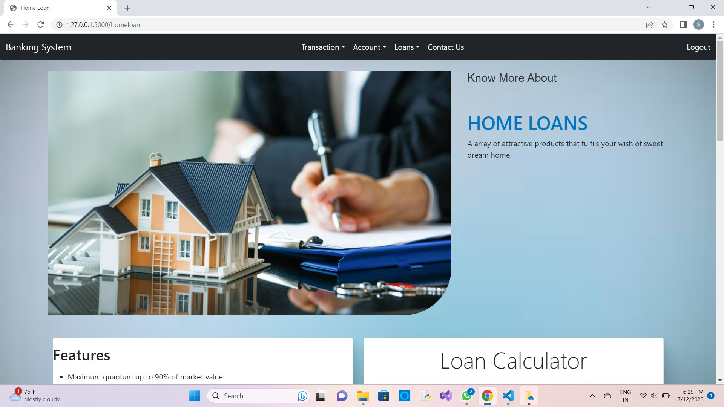

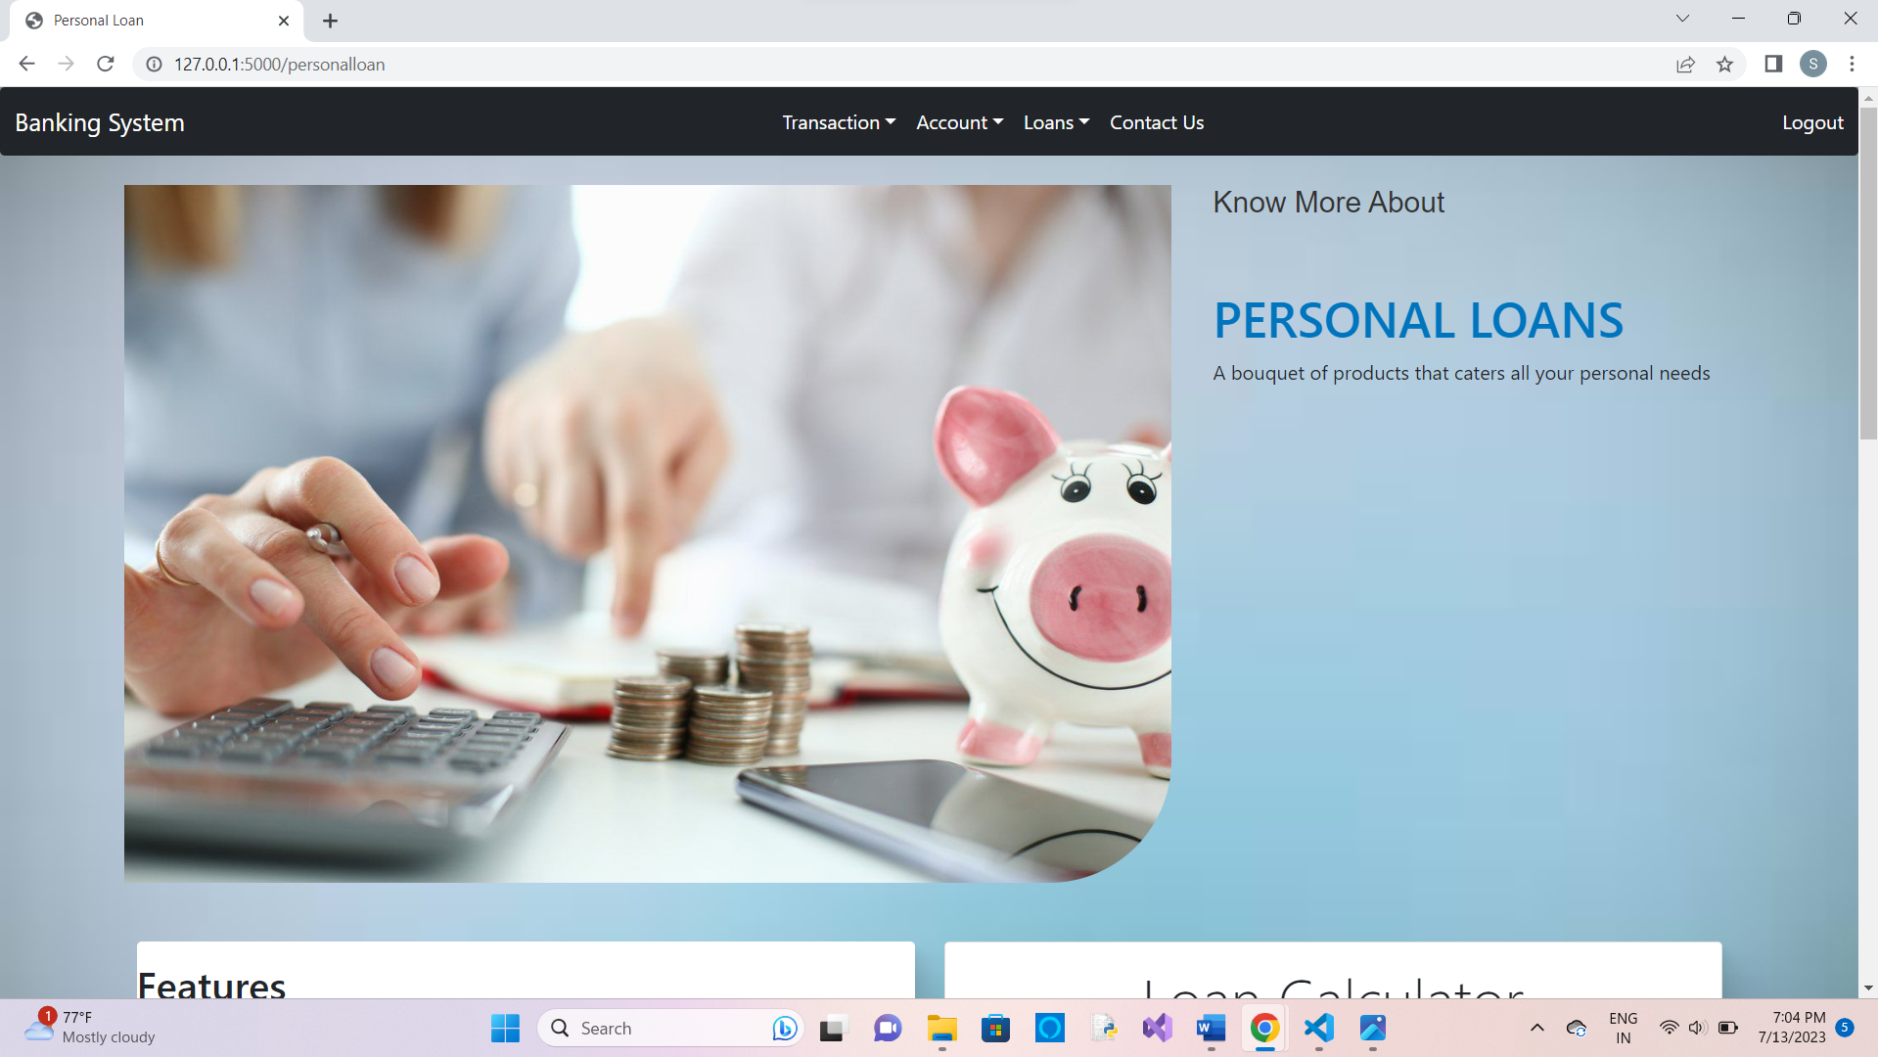

**10. Loan Calculator**

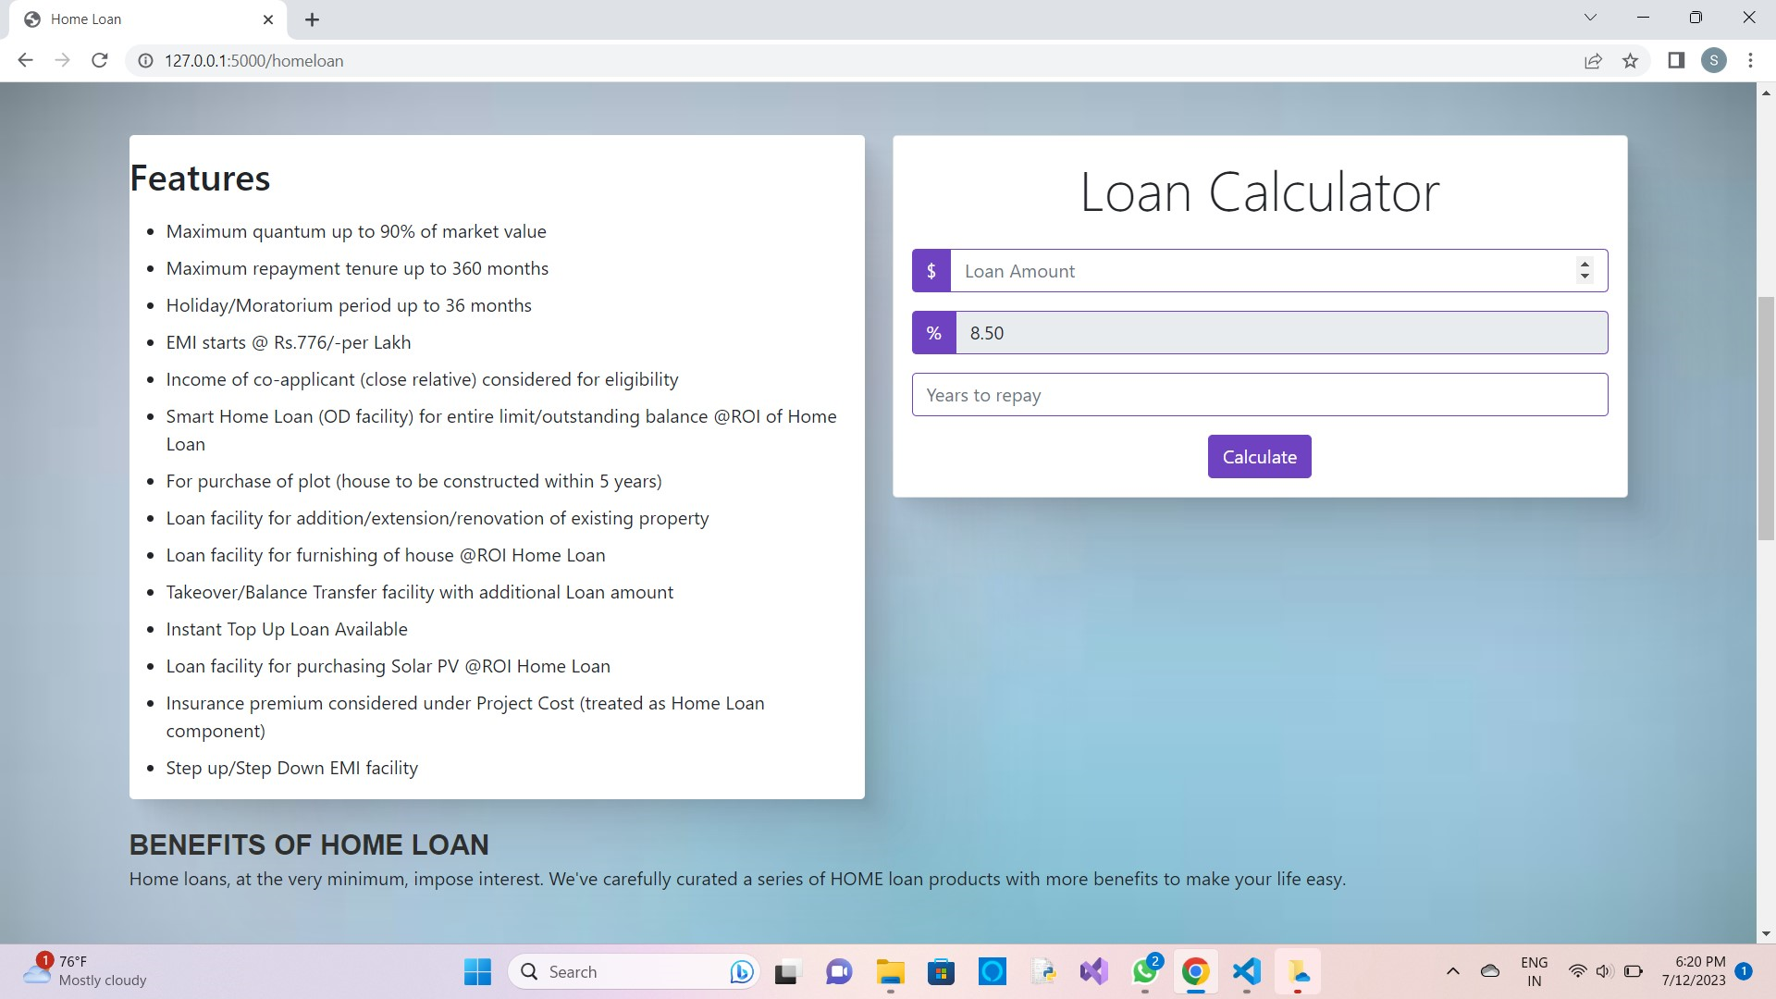

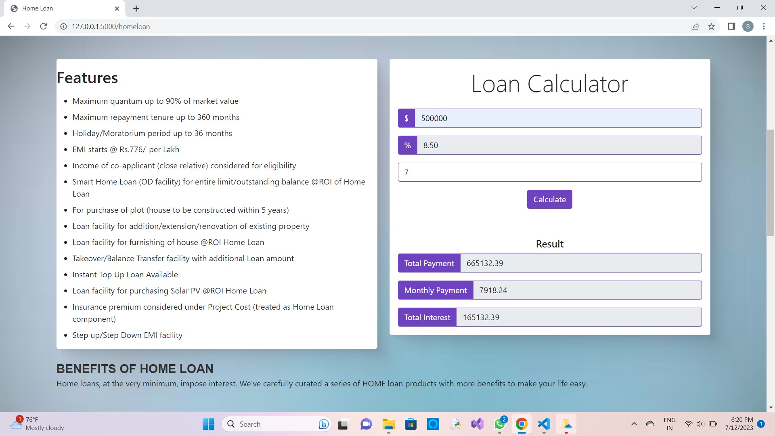

**11. Loan Application**

11.1 Check if account exists

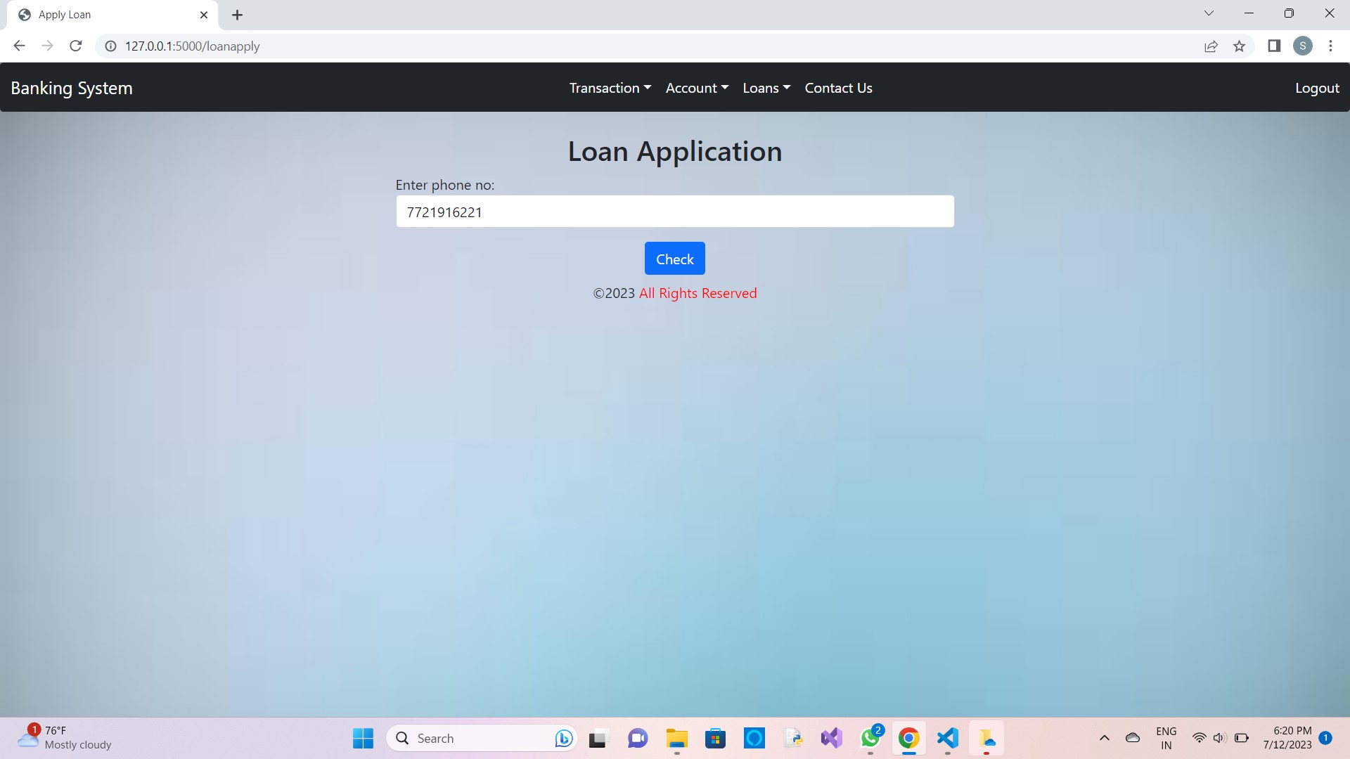

11.2 After confirming

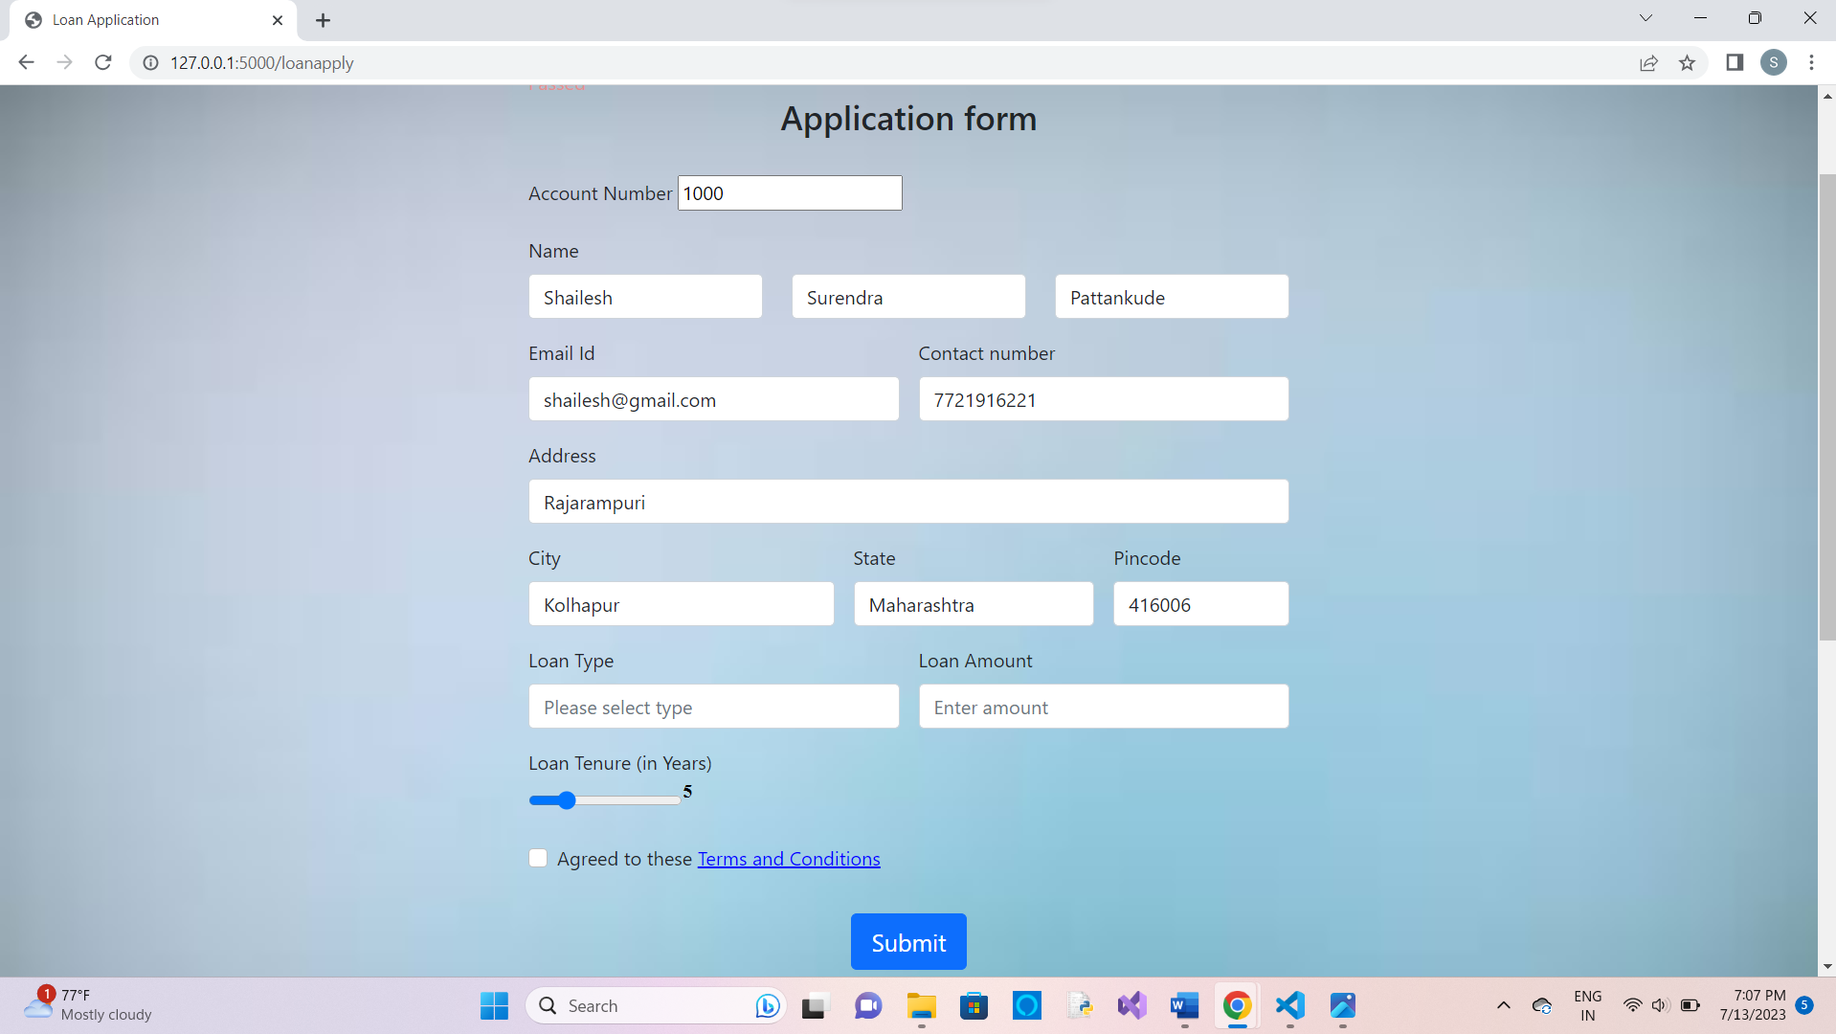

**12. Loan Application Download**

12.1 Check if loan is applied

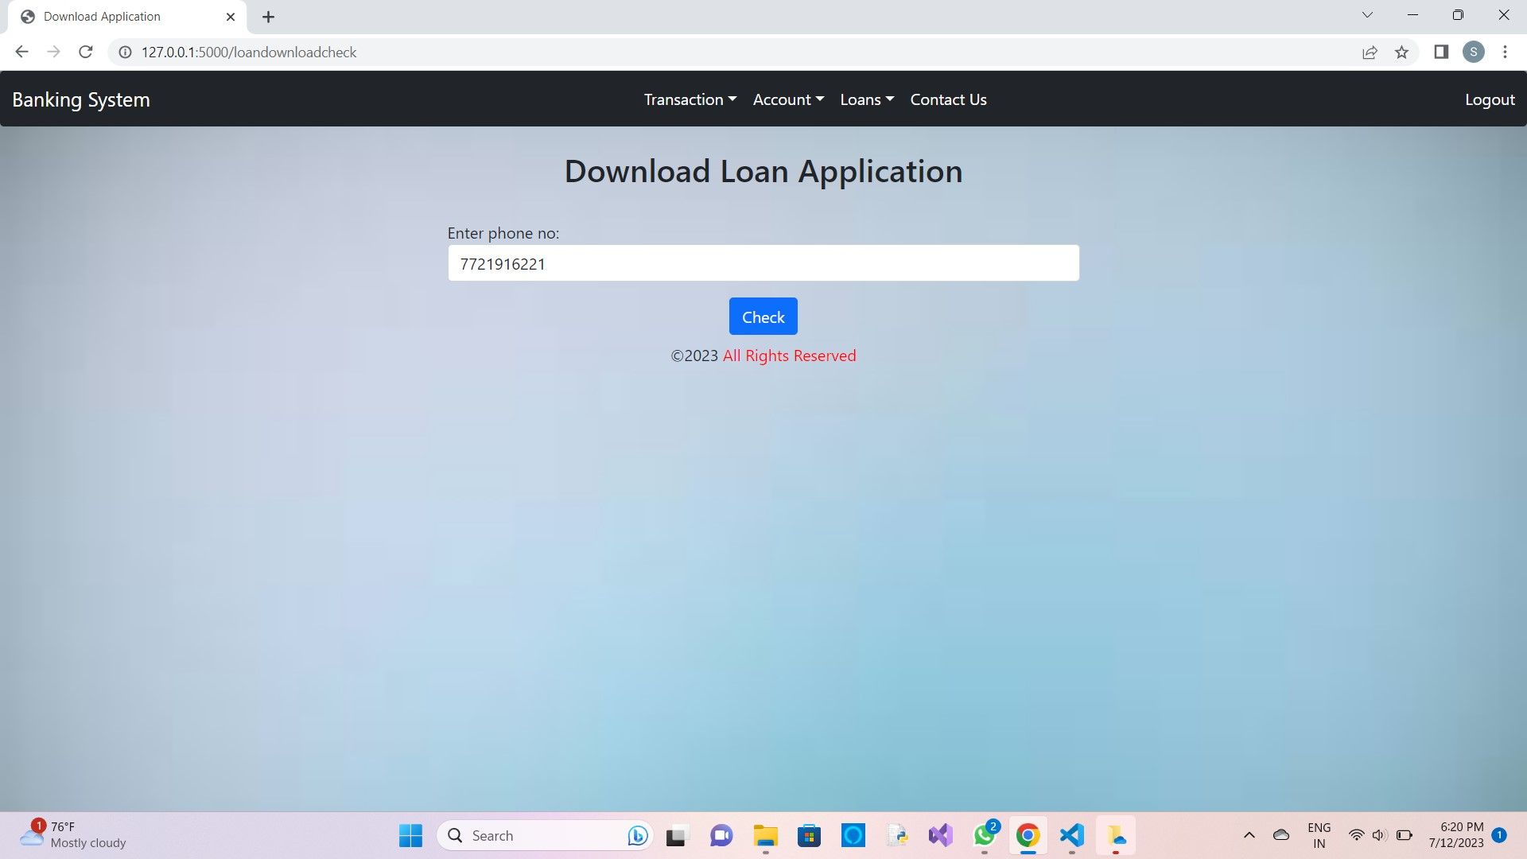

12.2 After confirming

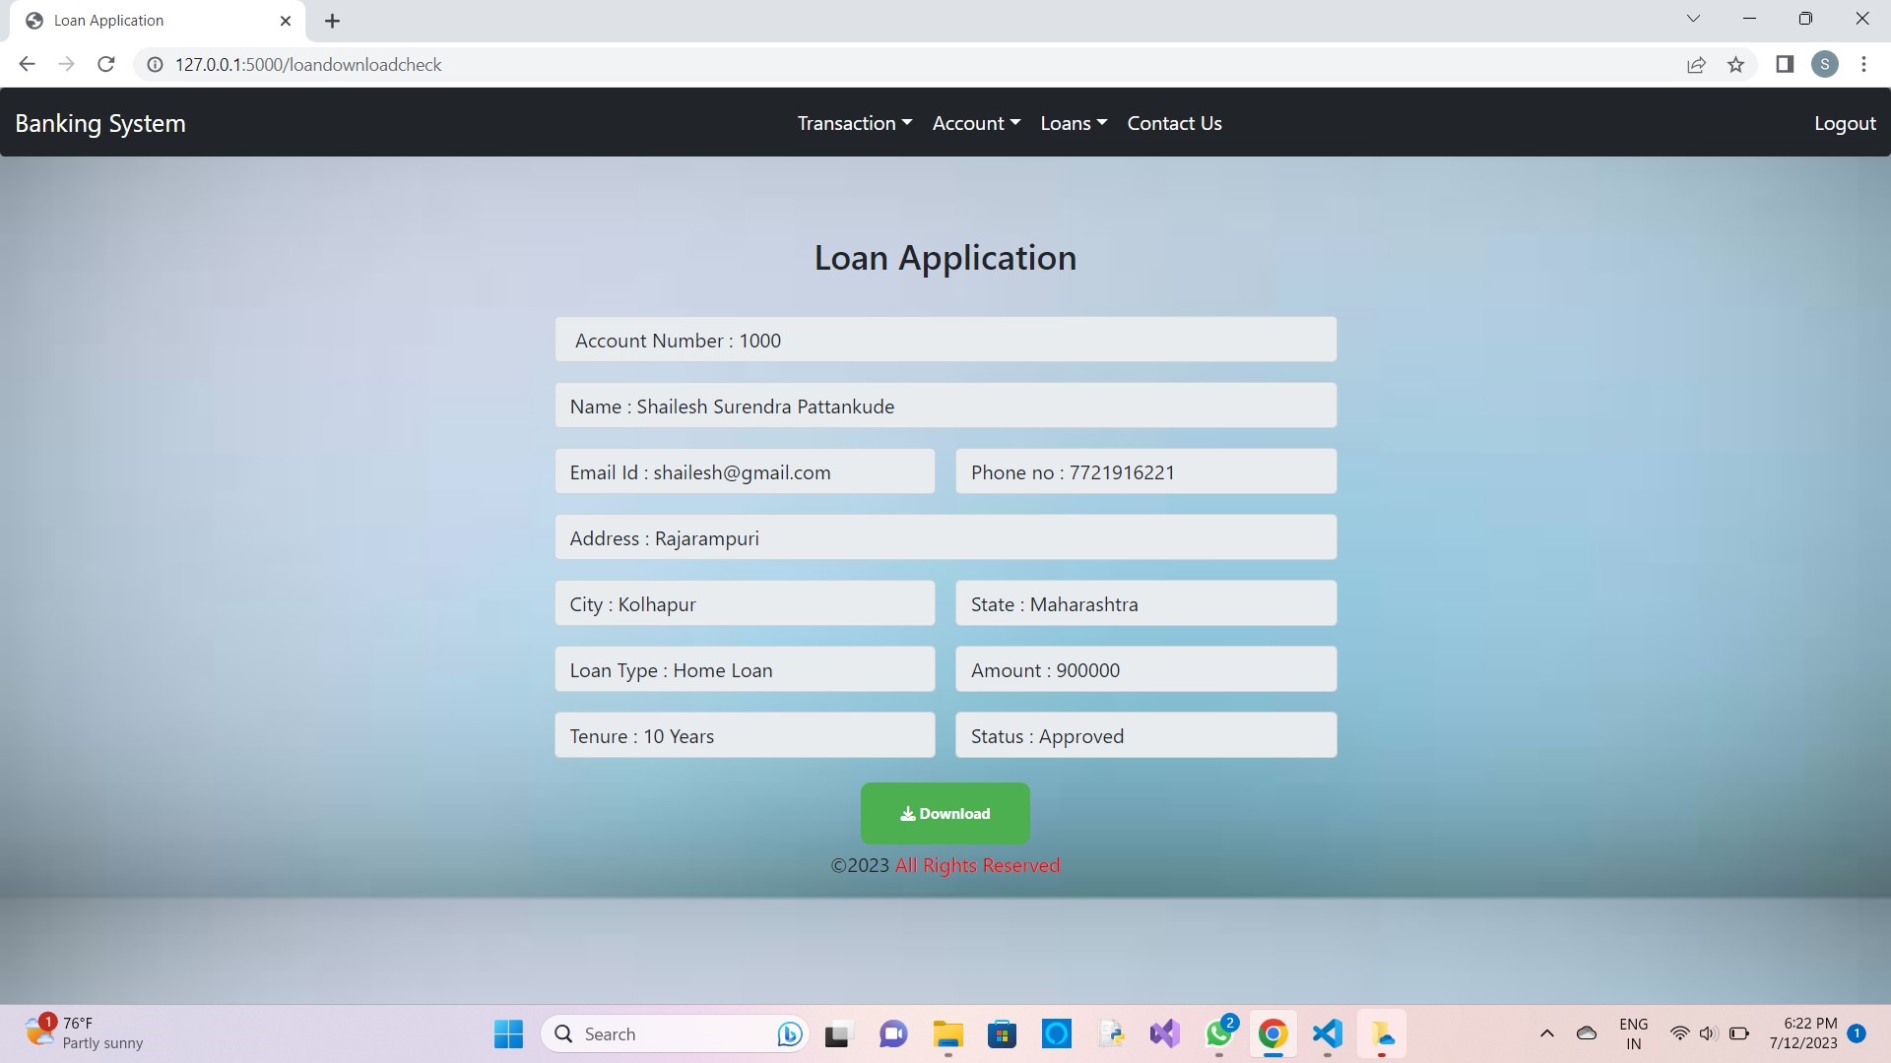

**13. Loan Amount, Rate, Tenure calculation**

13.1 Check if loan is applied

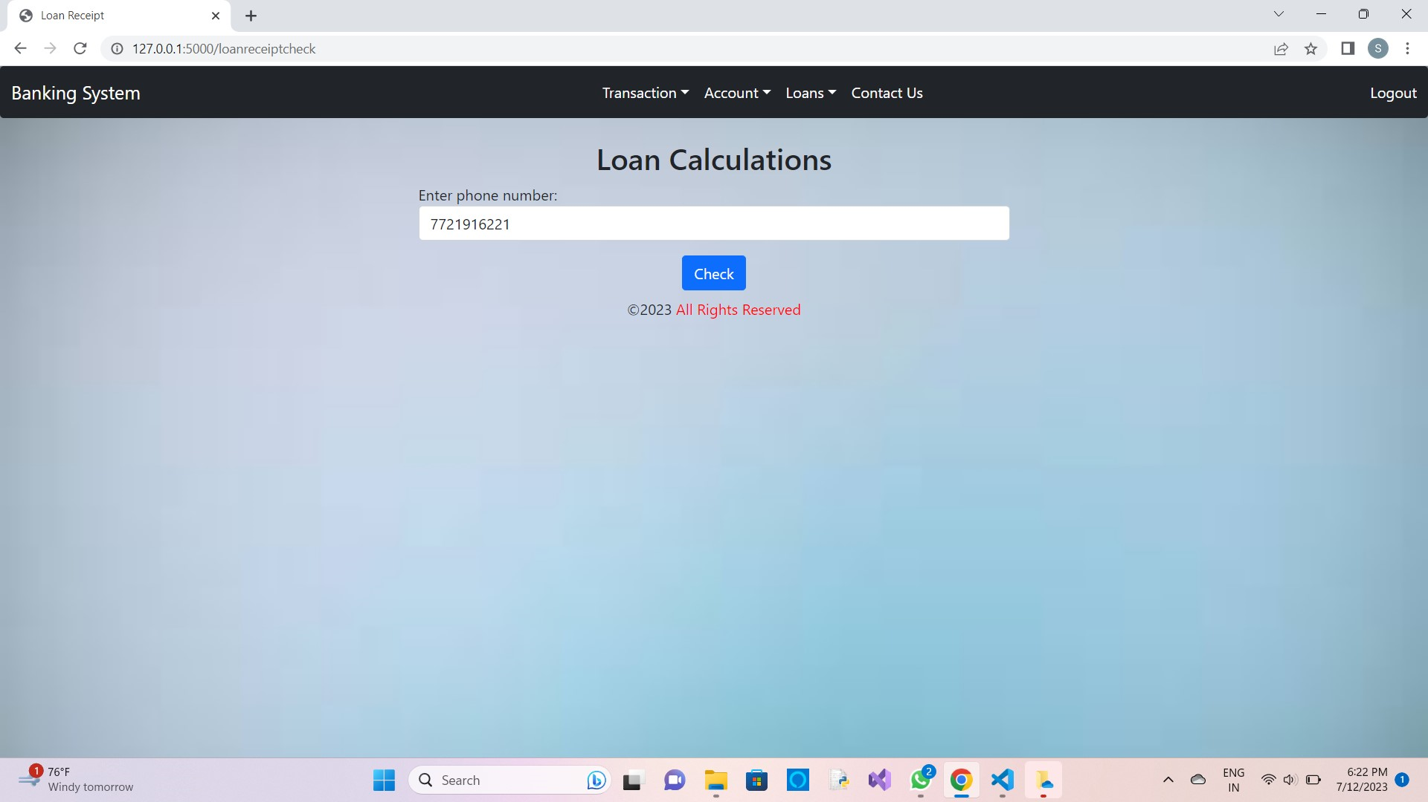

13.2 After confirming



**14. Contact Us**

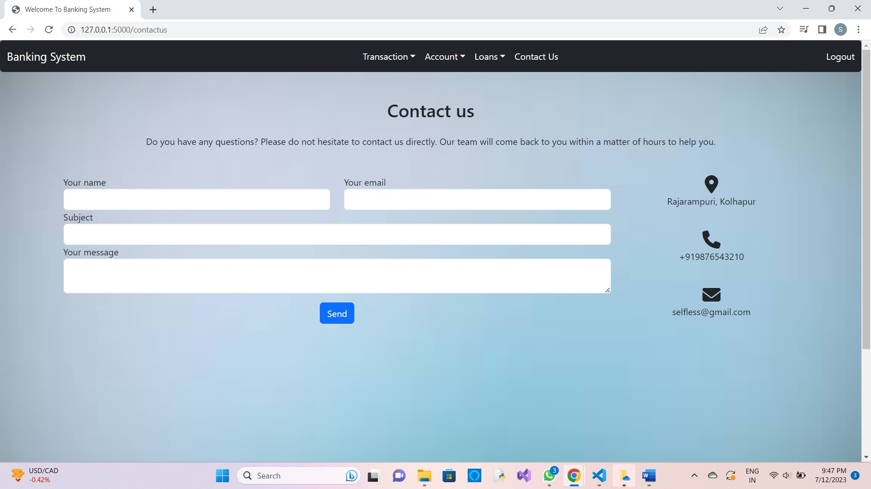

**9.2 Reports Screen**

**1. Accounts**

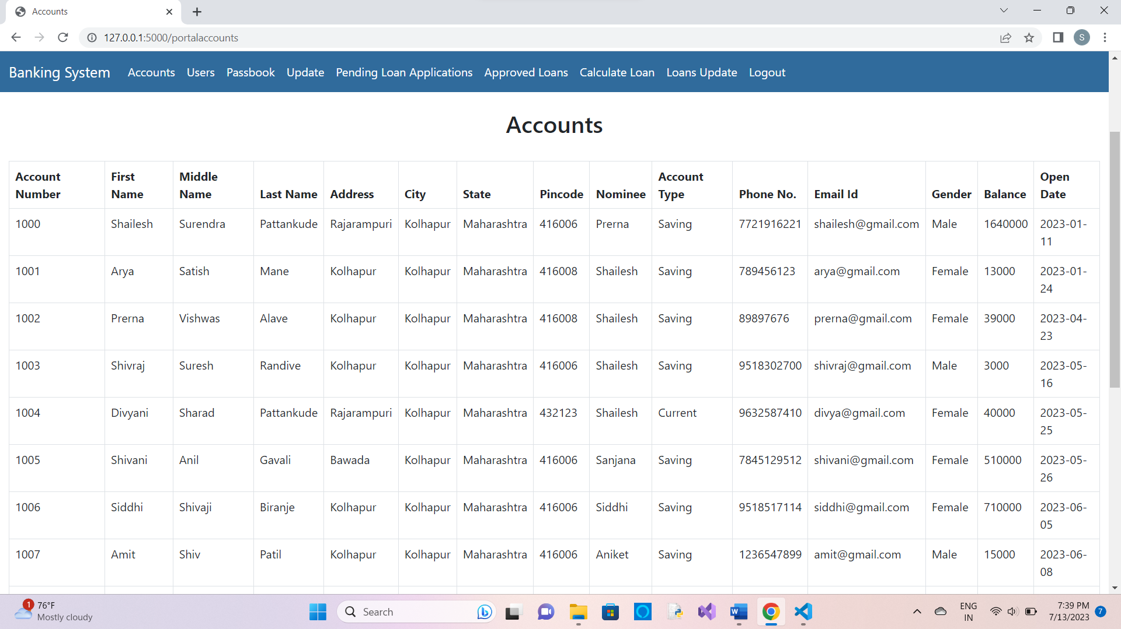

**2. Users**

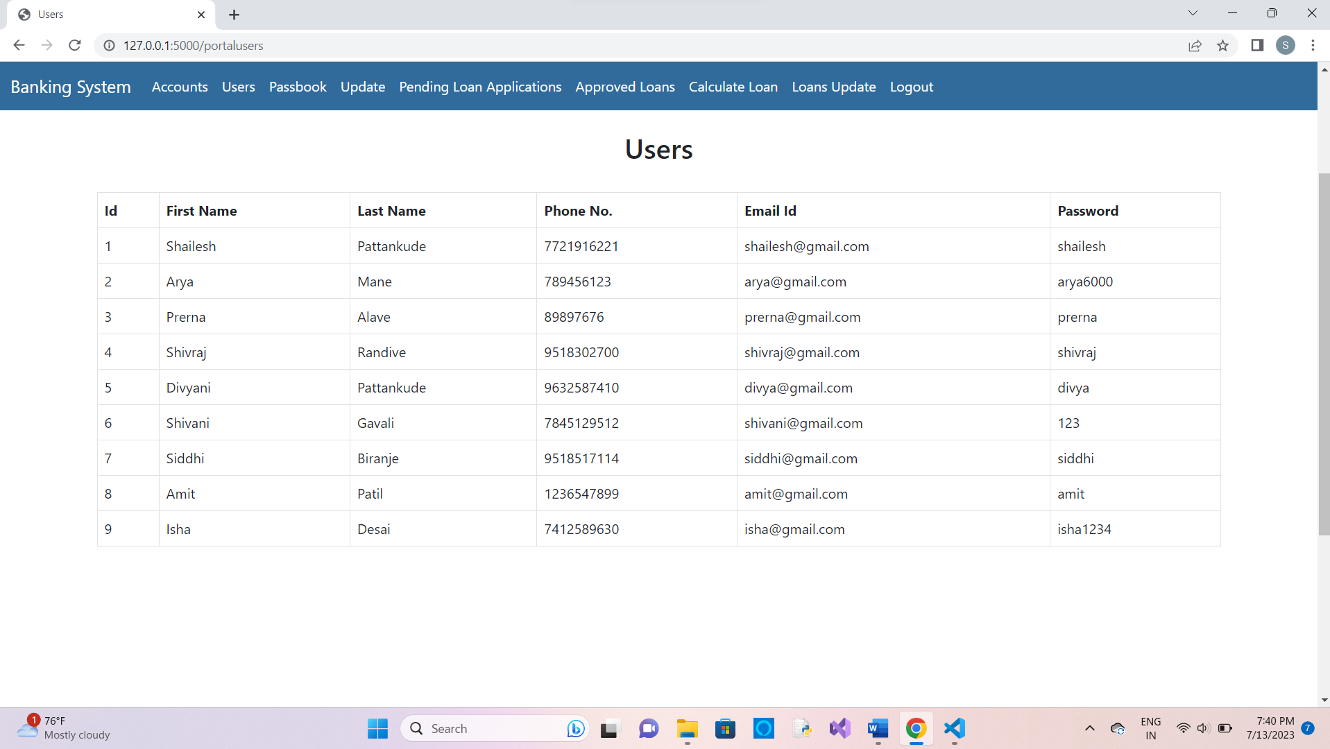

**3. Pending Loan Applications**

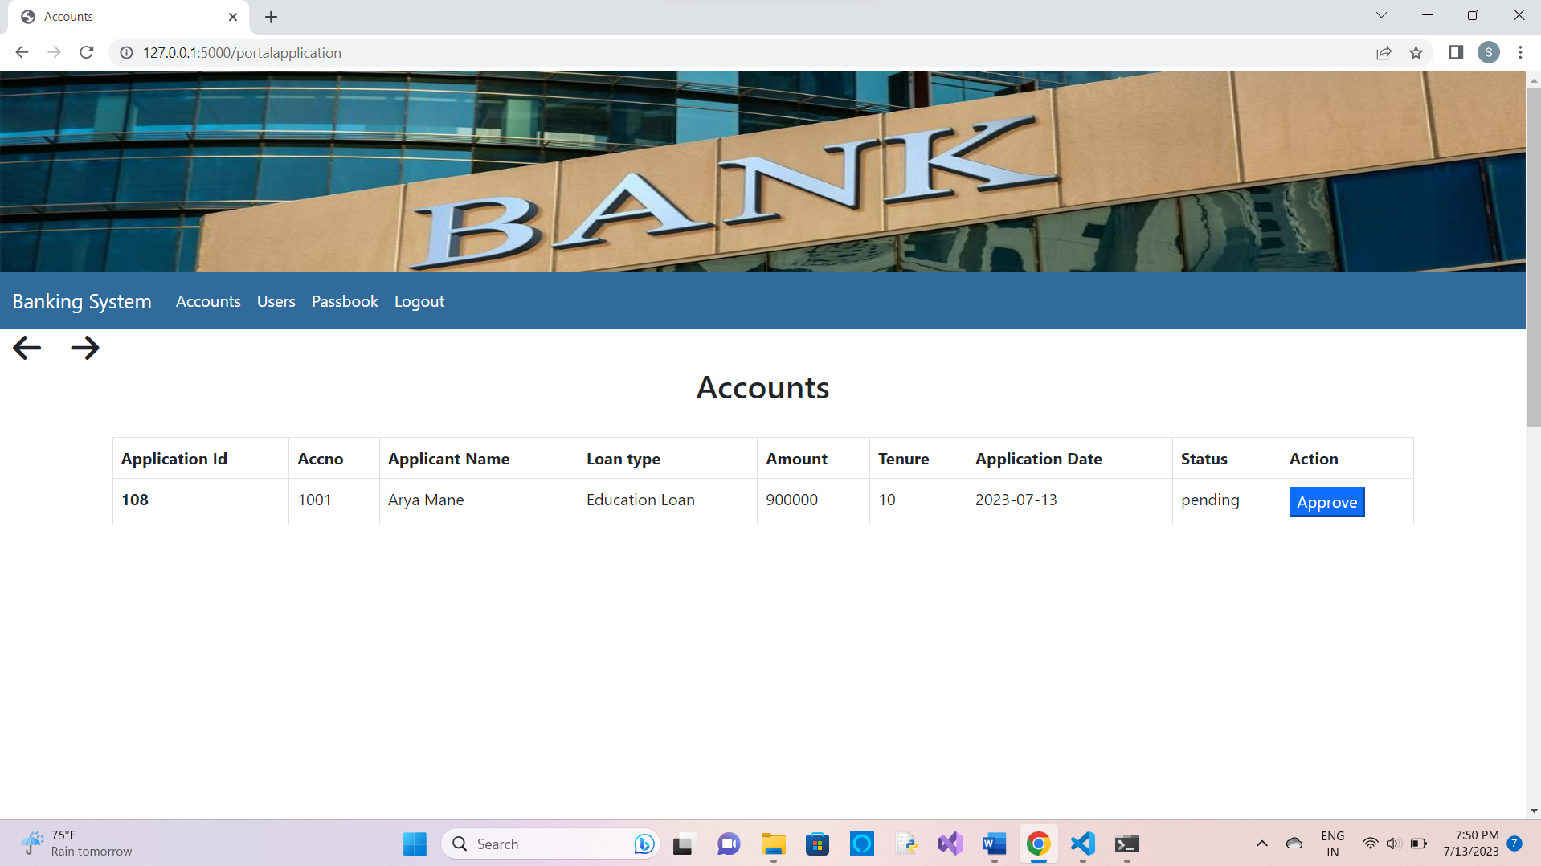

**4. Approved Loan Applications**

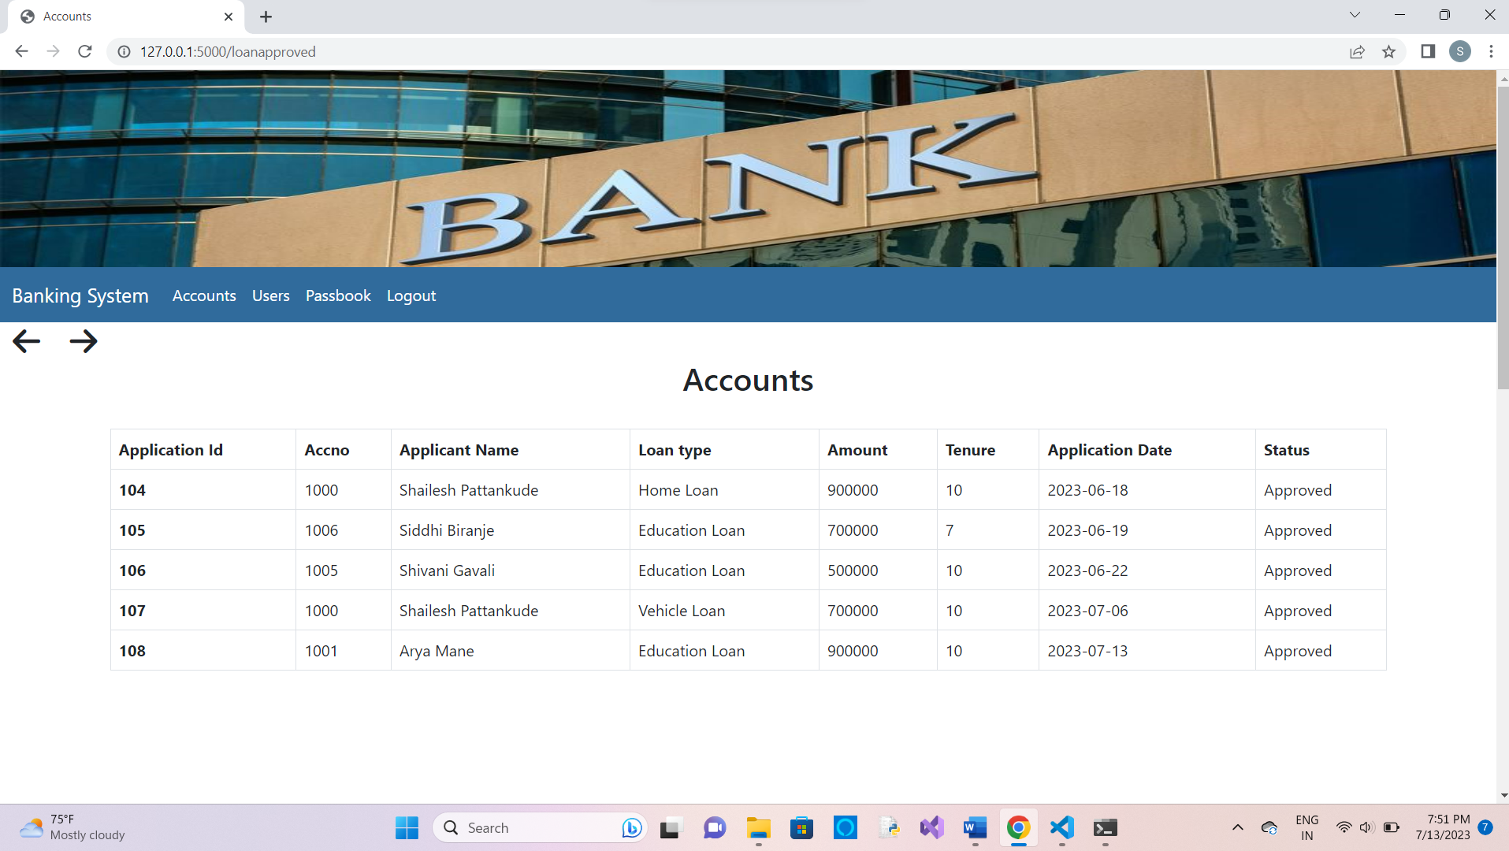

**5. Calculation of loan amount for user**

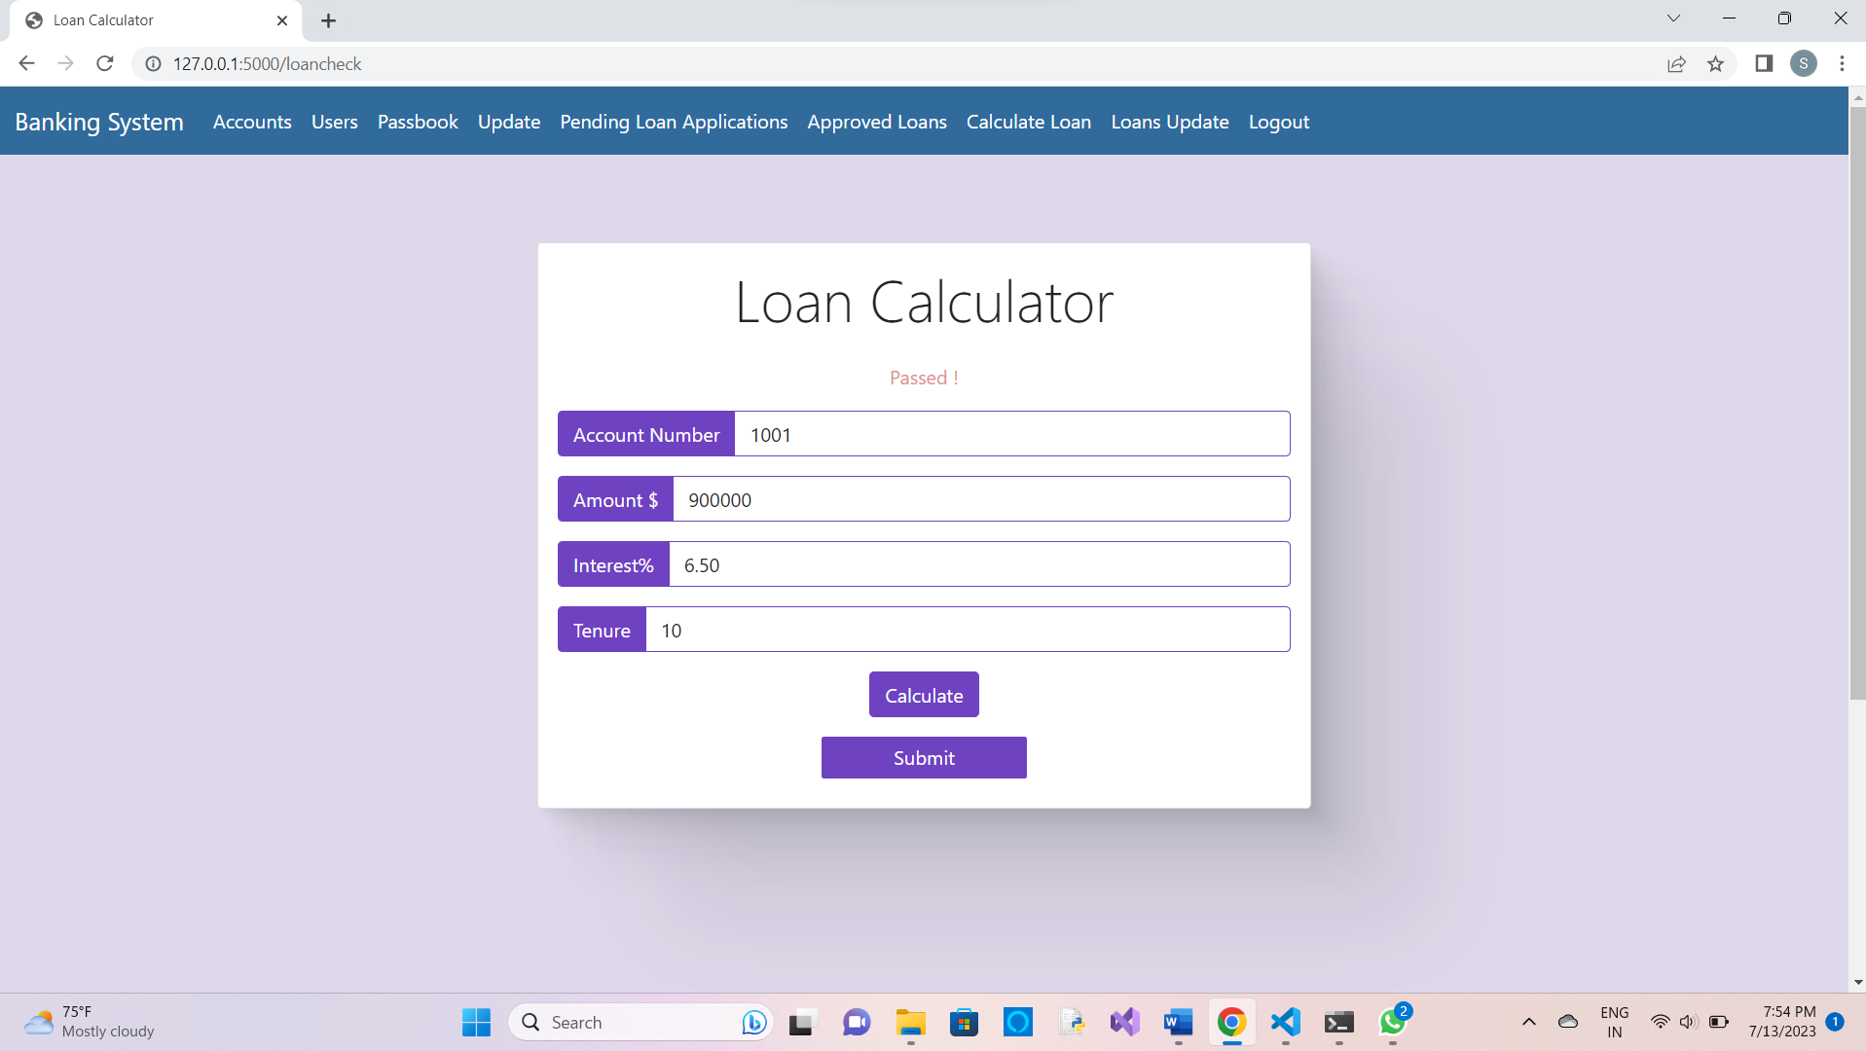

**After calculation it passes to user**

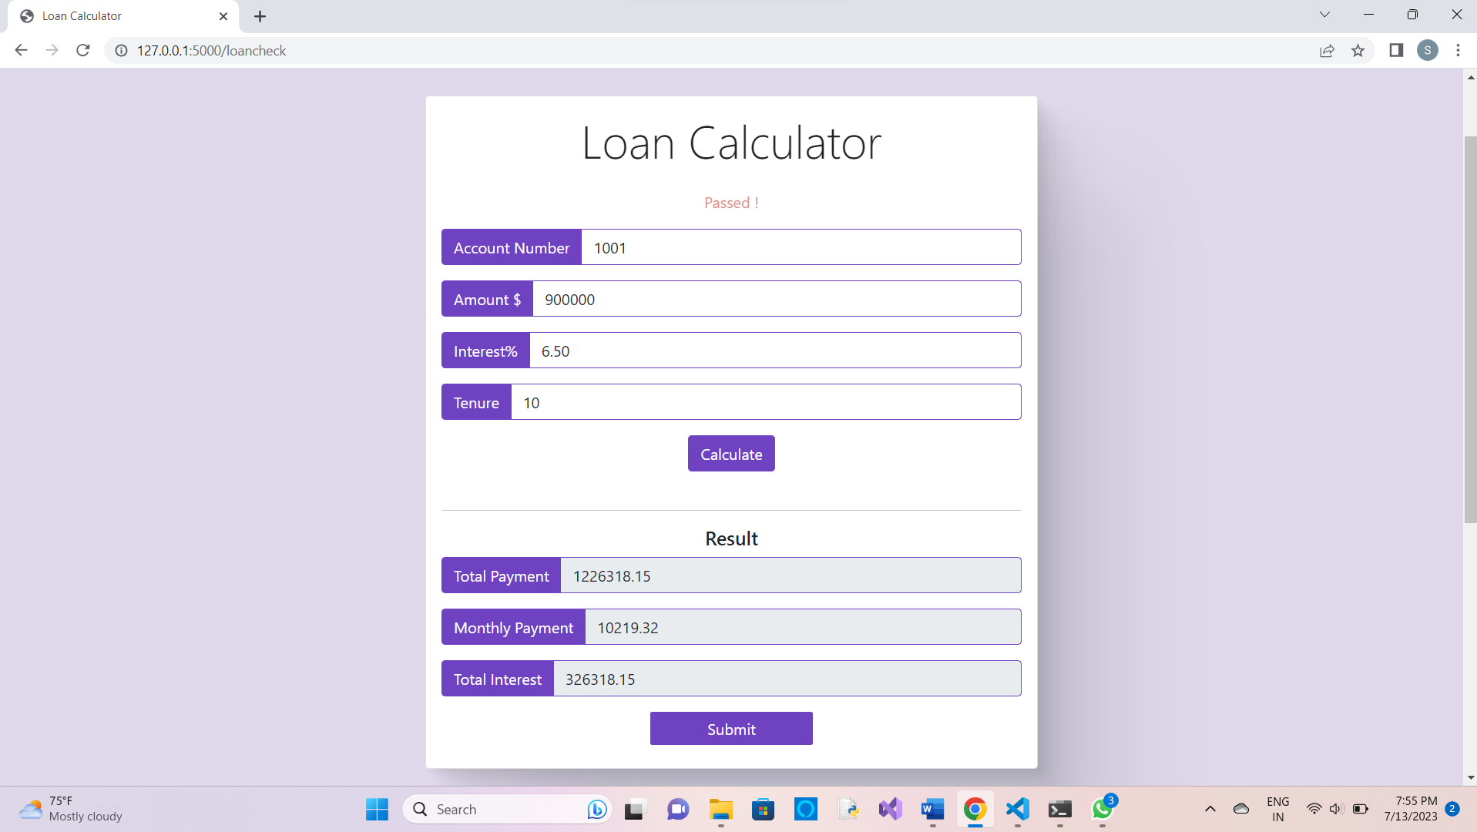

**6. Updating Loans**

